# S3 – Daily Tasks

1. Create an S3 bucket and upload some objects to S3.

* **Create S3 bucket**
  + Opened Amazon S3 console → **Create bucket**.
  + Selected Region **Europe (Stockholm) eu-north-1**.
  + Gave bucket name **techieeee-s3**.
  + Kept **Bucket type: General purpose**.
  + Left **Object ownership: ACLs disabled (recommended)** and created the bucket.
* **View the new bucket**
  + Went back to the **Buckets** list.
  + Saw **techieeee-s3** listed and clicked the bucket name to open it.
* **Open Objects tab and start upload**
  + Inside the bucket, stayed on the **Objects** tab.
  + Clicked the **Upload** button.
* **Select file to upload**
  + On the **Upload** page, added a PNG file  
    (ChatGPT Image Dec 2, 2025, 12_11_13 PM.png) to the “Files and folders” list.
  + Confirmed the **Destination** is s3://techieeee-s3.
  + Clicked **Upload**.
* **Confirm upload success**
  + Saw **Upload: status** page showing **Succeeded – 1 file, 1.6 MB (100%)**.
* **Open the uploaded object**
  + Clicked the uploaded object name in the bucket.
  + On the object **Properties** tab, noted:
    - **Key** (object name)
    - **Object URL** and S3 URI.
* **Test public URL**
  + Copied the **Object URL** and opened it in the browser.
  + Browser showed an XML error with <Code>AccessDenied</Code>.
* **Go to bucket permissions**
  + Returned to the bucket view.
  + Switched to the **Permissions** tab.
  + Clicked **Edit** under **Object Ownership** / permissions area.
* **Enable ACLs (Object Ownership)**
  + On **Edit Object Ownership** page:
    - Changed from **ACLs disabled (recommended)** to **ACLs enabled**.
    - Checked the acknowledgment box.
    - Chose **Bucket owner preferred** for object ownership.
  + Clicked **Save changes**.
* **Change Block Public Access settings**
  + Still on the **Permissions** tab, clicked **Edit** under **Block public access (bucket settings)**.
  + On the **Edit Block public access** page, **unchecked “Block all public access”** (and therefore its sub-options).
  + Clicked **Save changes**.
* **View Object Permissions (ACL)**
* Opened the uploaded object → went to **Permissions** tab.
* Saw the **Access control list (ACL)** section showing “This bucket has the bucket owner enforced setting applied for Object Ownership”.
* Confirmed that ACL settings are visible but not yet granting public access.
* **Make Object Public using ACL**
* Returned to the **Objects** tab inside the bucket.
* Selected the uploaded file (ChatGPT Image Dec 2, 2025, 12_11_13 PM.png).
* Clicked **Actions** dropdown.
* Chose **Make public using ACL**.
* AWS applied **public-read** permission to the object.
* **Access the Public Object URL**
* Copied the **Object URL** again.
* Opened it in the browser.

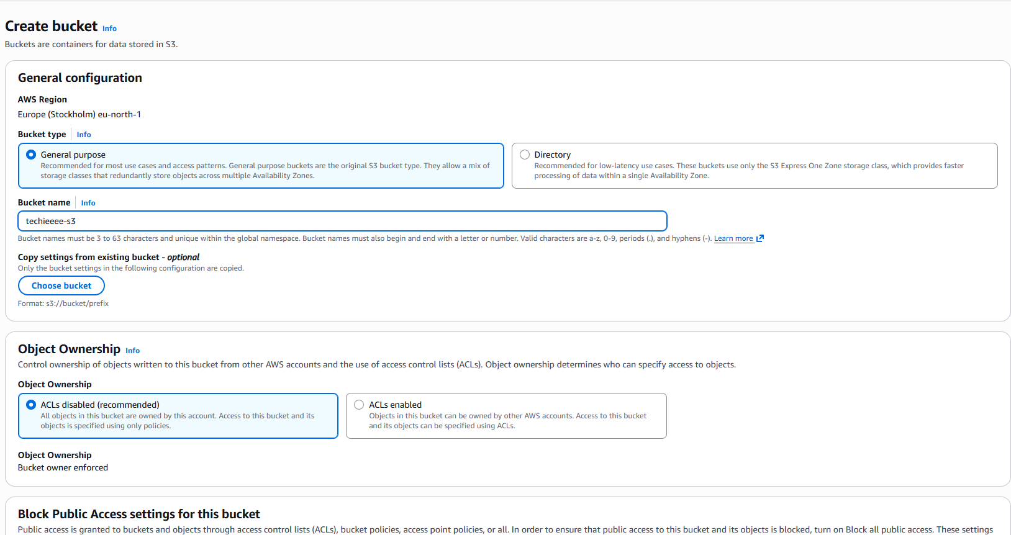

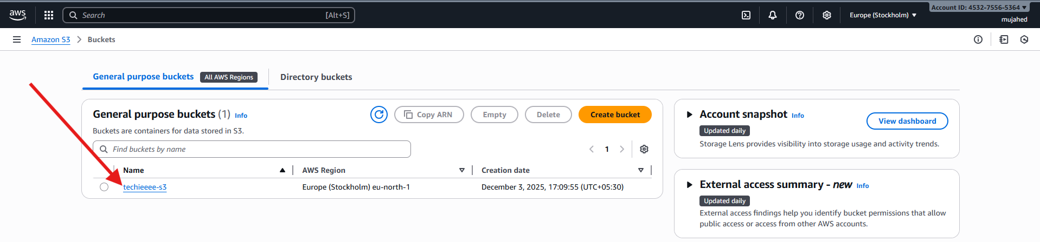

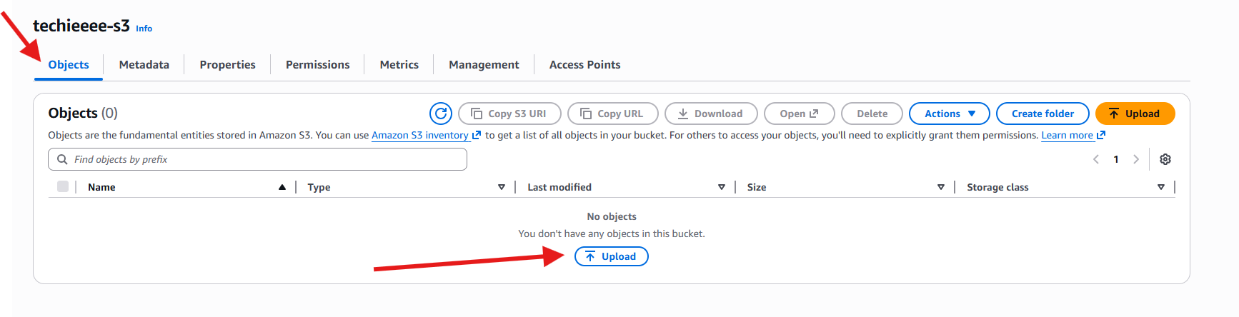

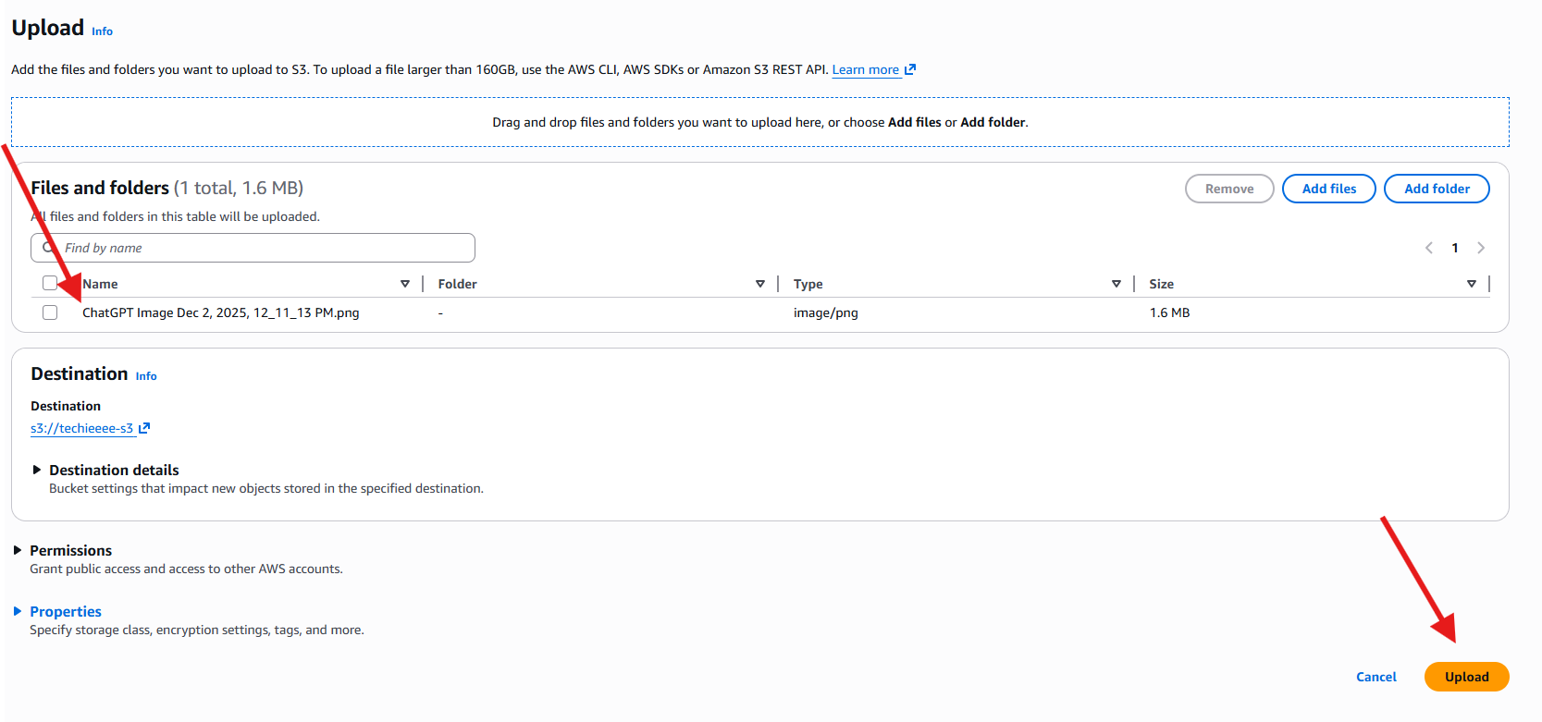

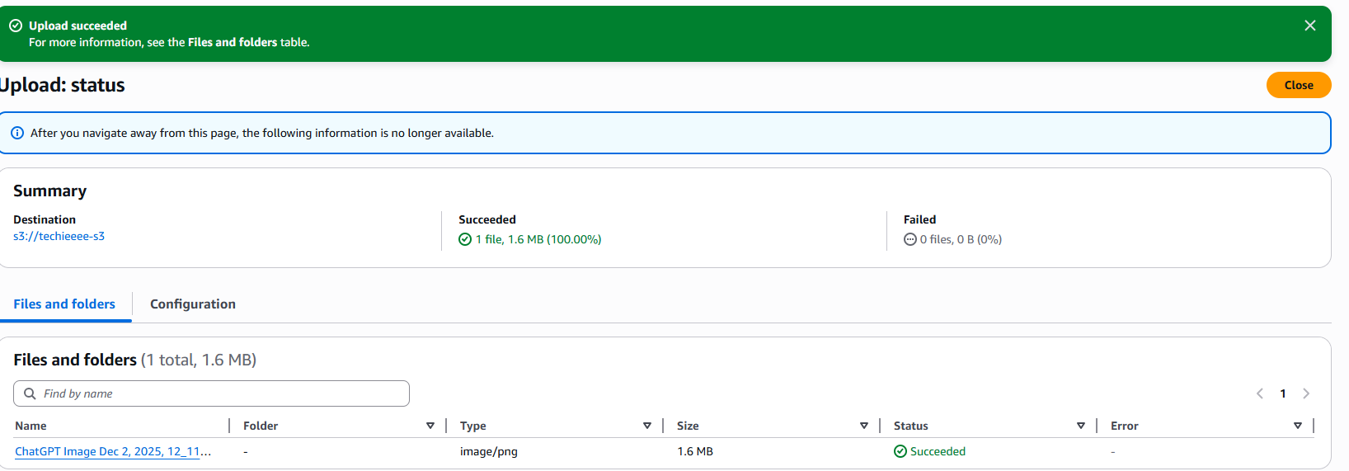

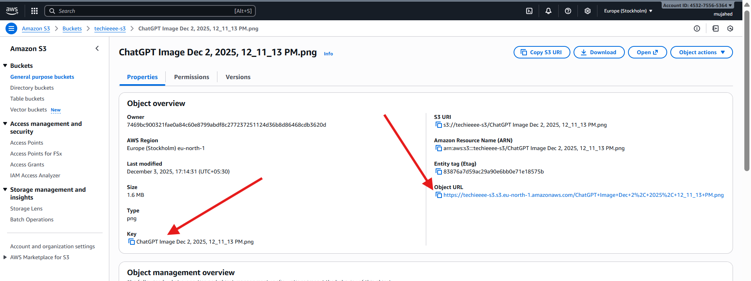

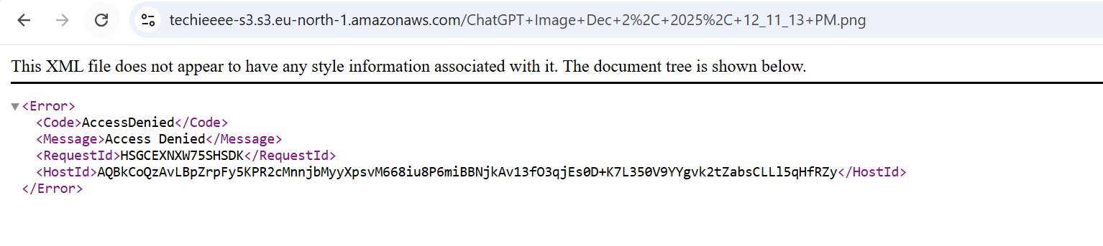

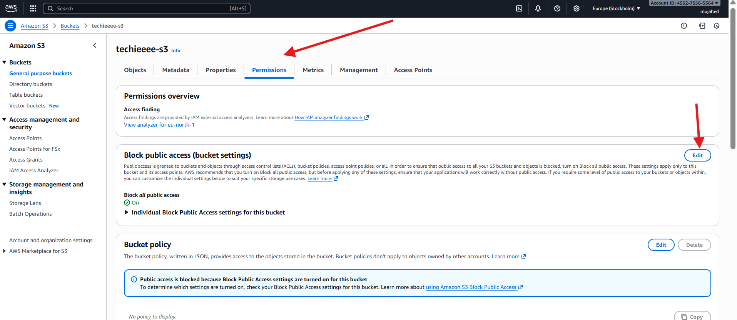

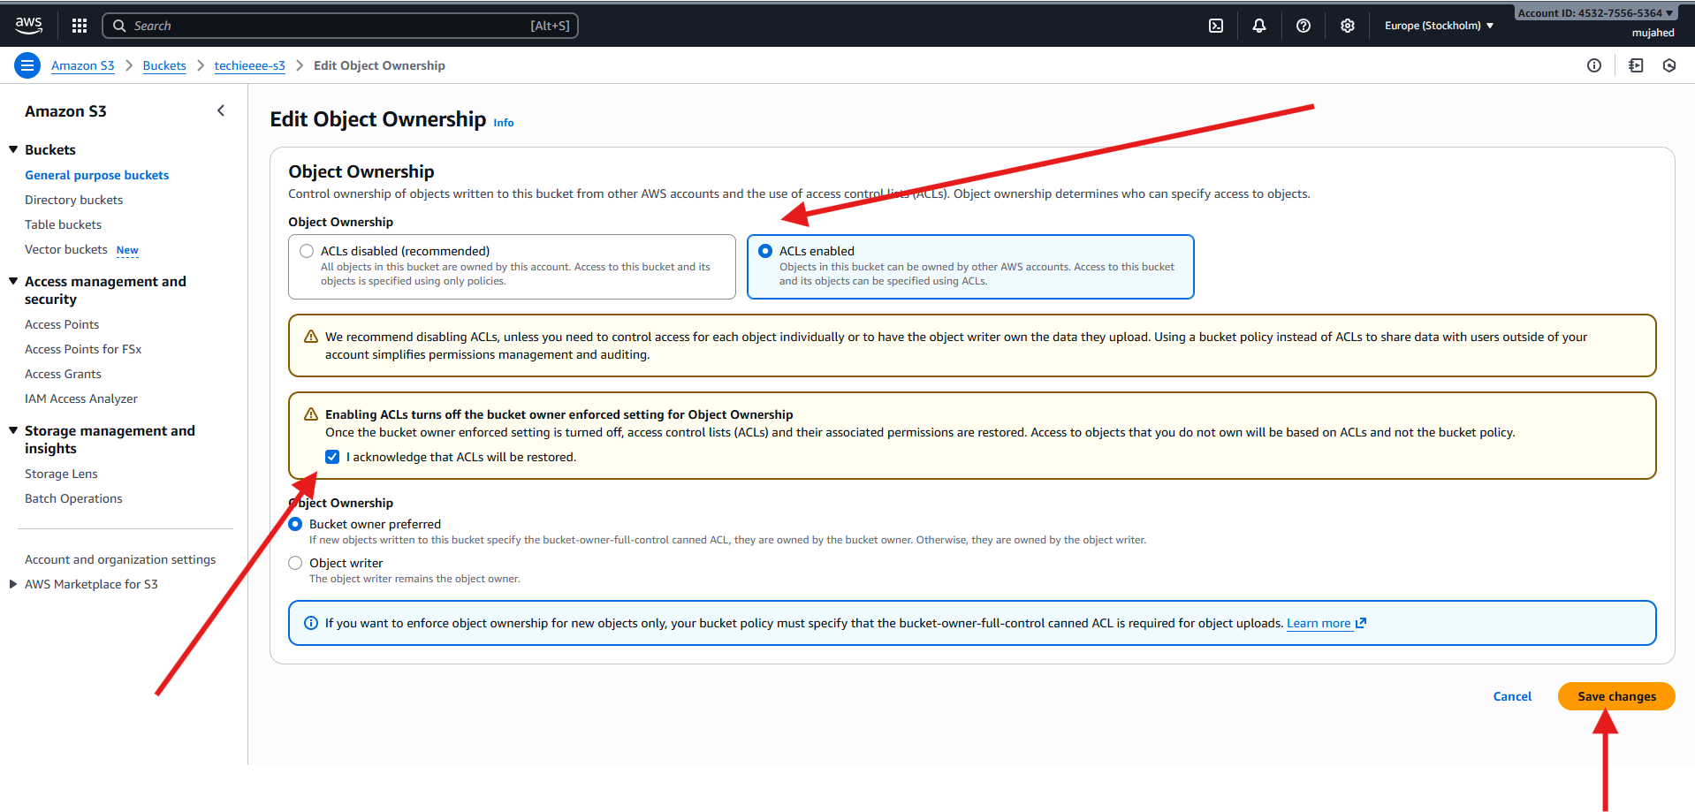

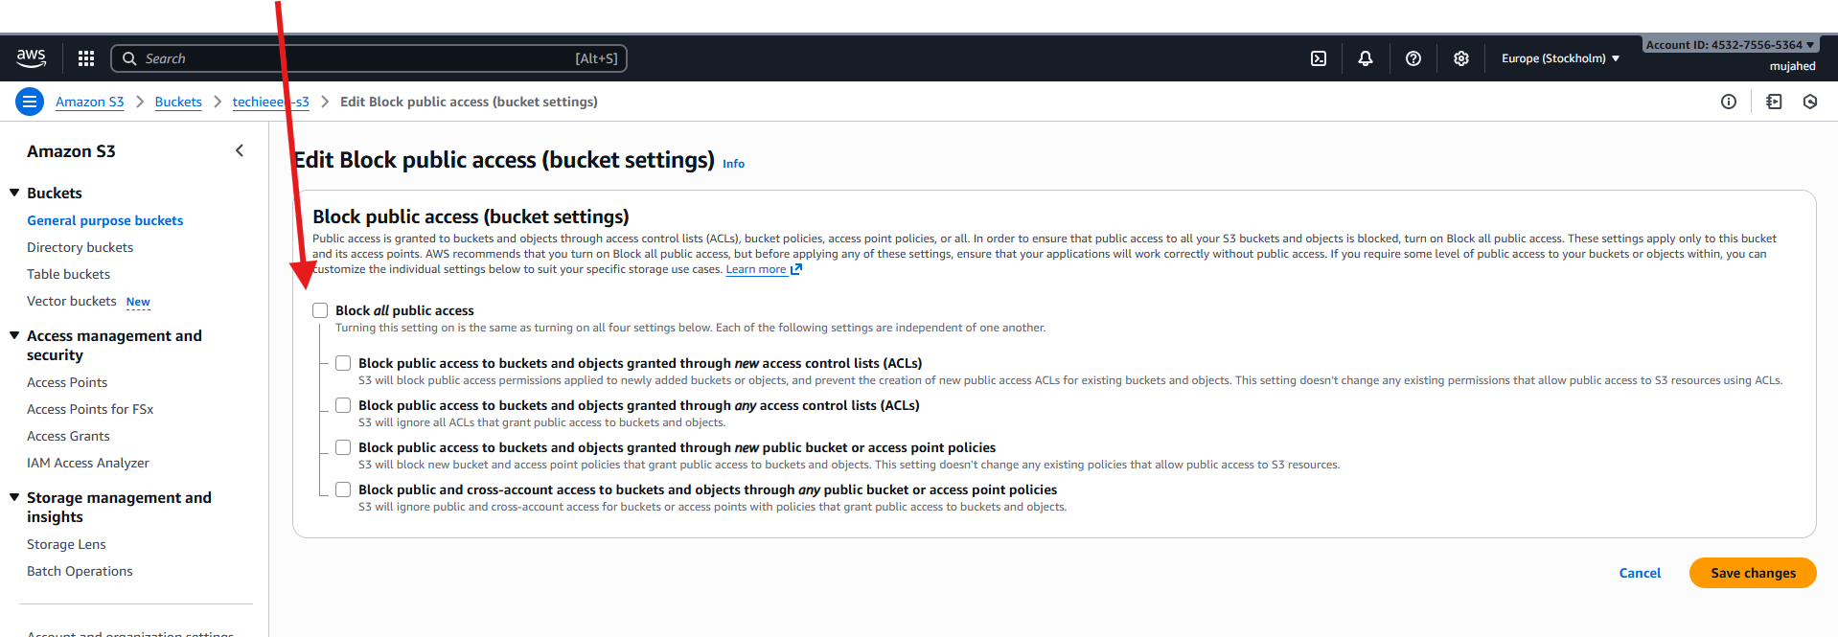

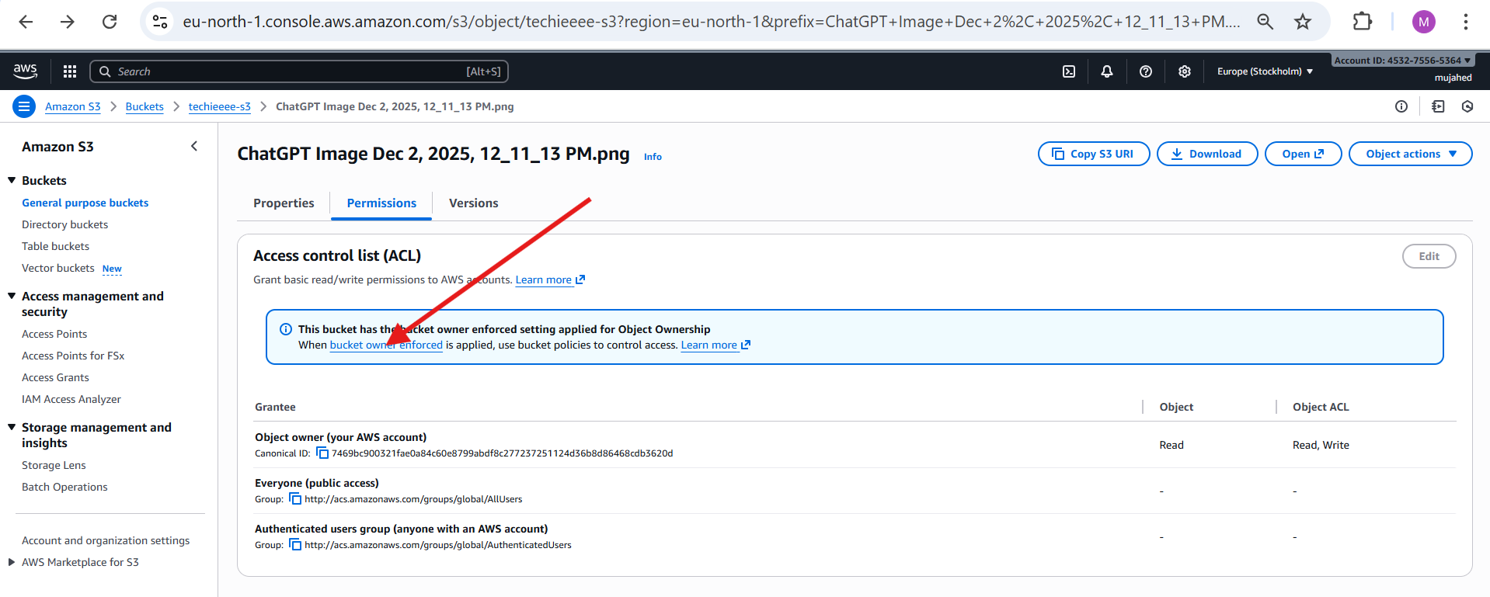

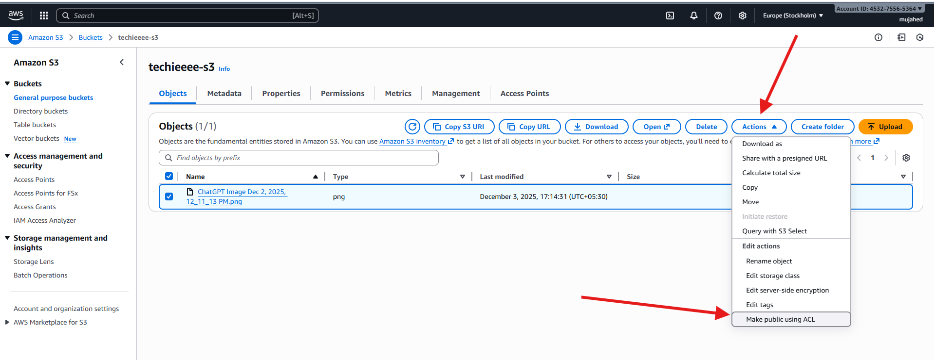

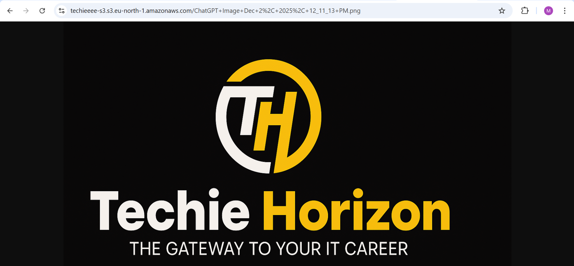

1. Deploy a static website in the S3 bucket.

* **Upload Website Files to S3**
* Open the S3 bucket → **Objects** tab
* Click **Upload**
* Click **Add files**
* Select your website files → index.html and error.html
* Confirm destination is your bucket → **techieeee-s3**
* Click **Upload**
* **Make Files Public**
* Select both index.html and error.html
* Click **Actions** → **Make public using ACL**  
   This allows the public to view your website pages.
* **Enable Static Website Hosting**
* Go to bucket → **Properties** tab
* Scroll to the **Static website hosting** section
* Choose:
  + **Enable**
  + **Hosting type: Bucket hosting**
  + **Index document: index.html**
  + **Error document: error.html**
* Click **Save changes**
* **Access Your Website**
* Copy the **Bucket website endpoint** URL  
  Example:
* http://techieeee-s3.s3-website.eu-north-1.amazonaws.com
* Paste in browser
* **Website Error Page Works**
* If a user opens a wrong URL  
  → It redirects to **error.html**

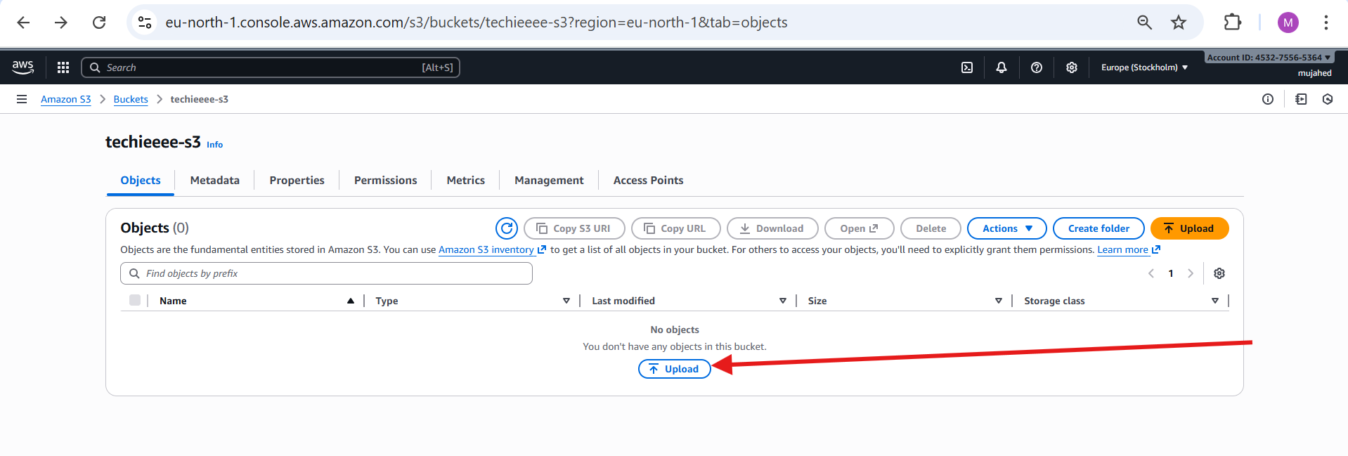

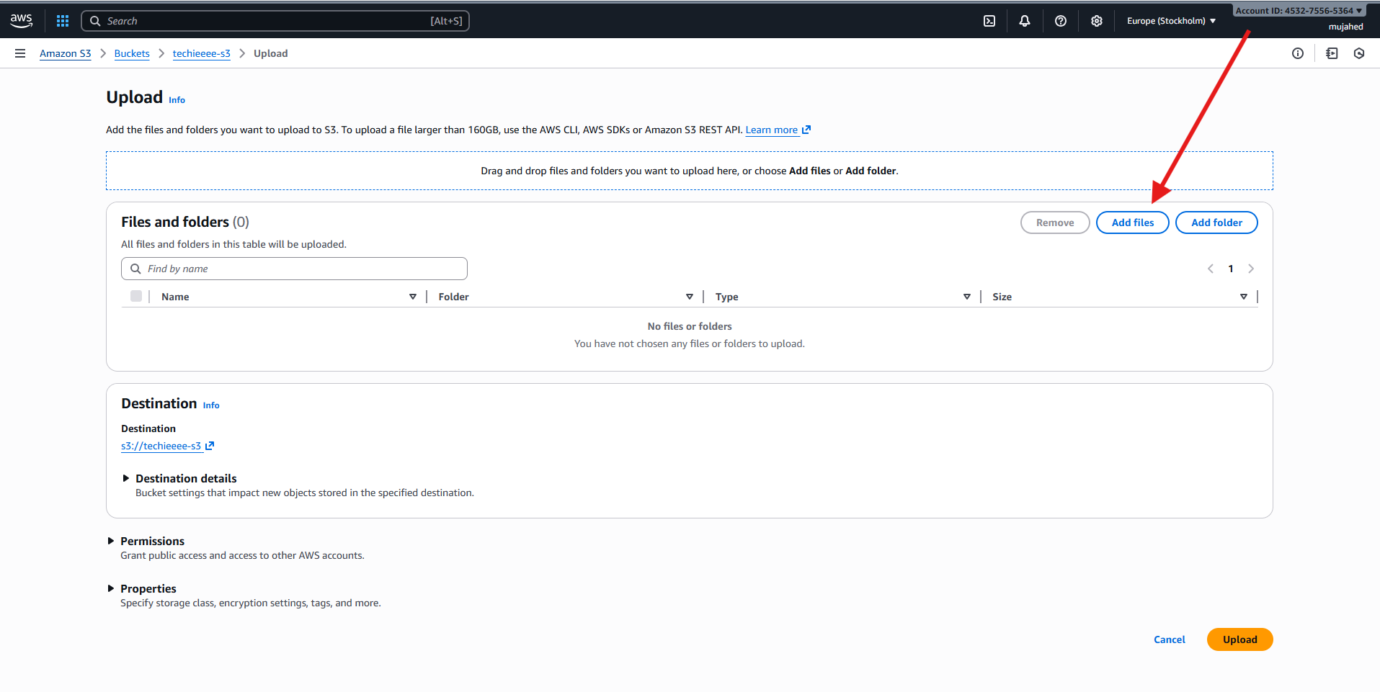

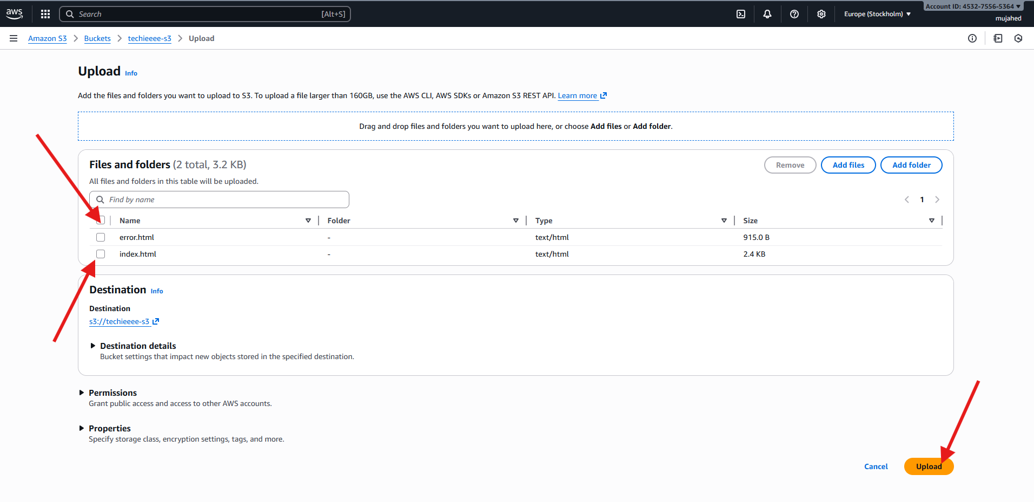

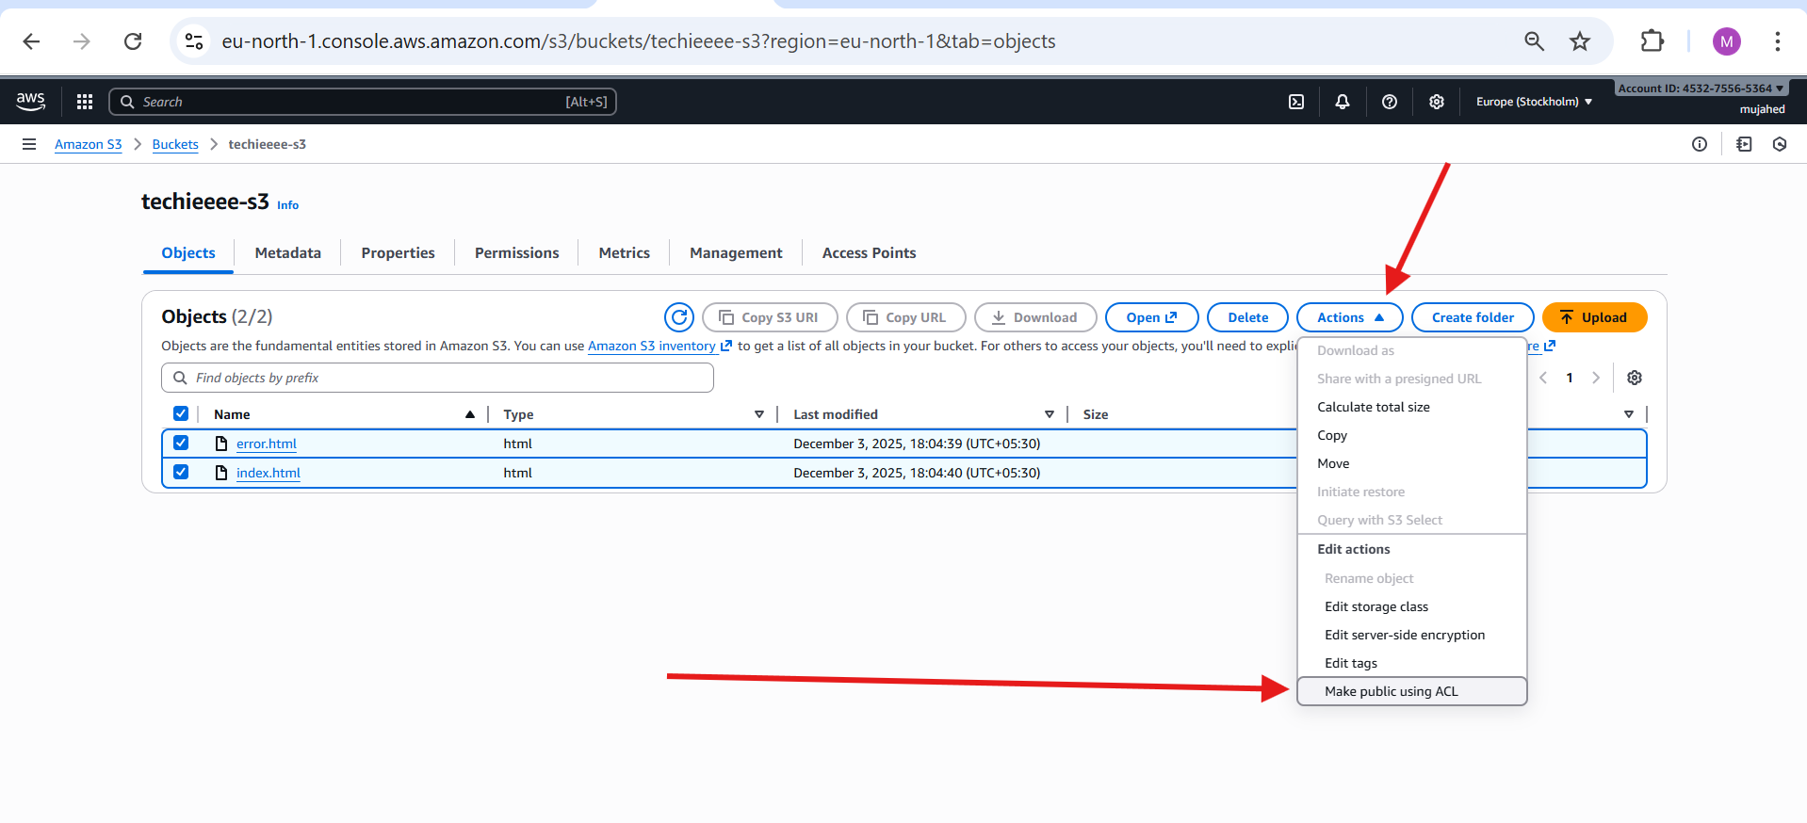

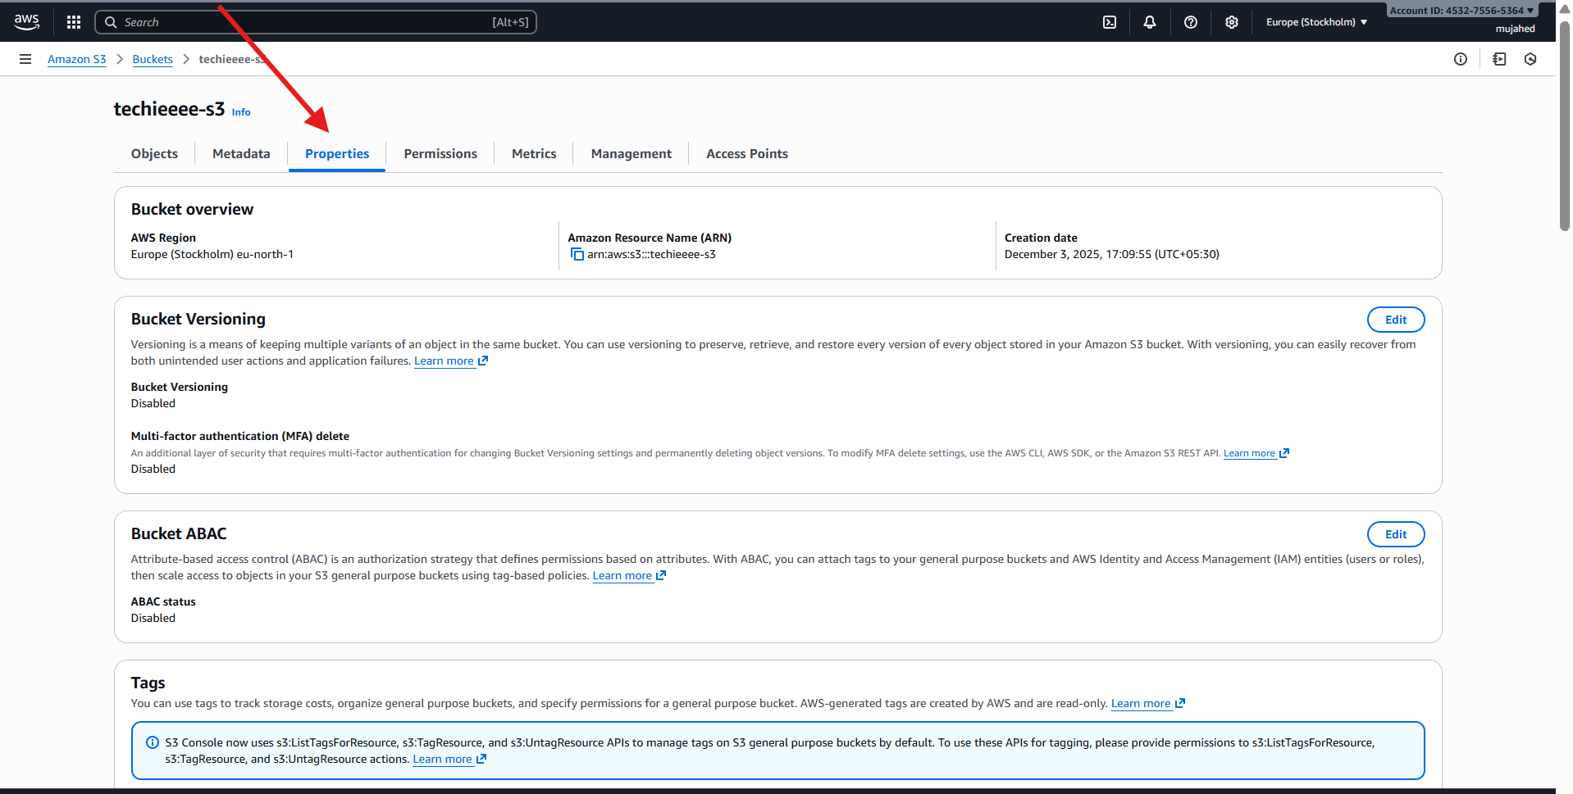

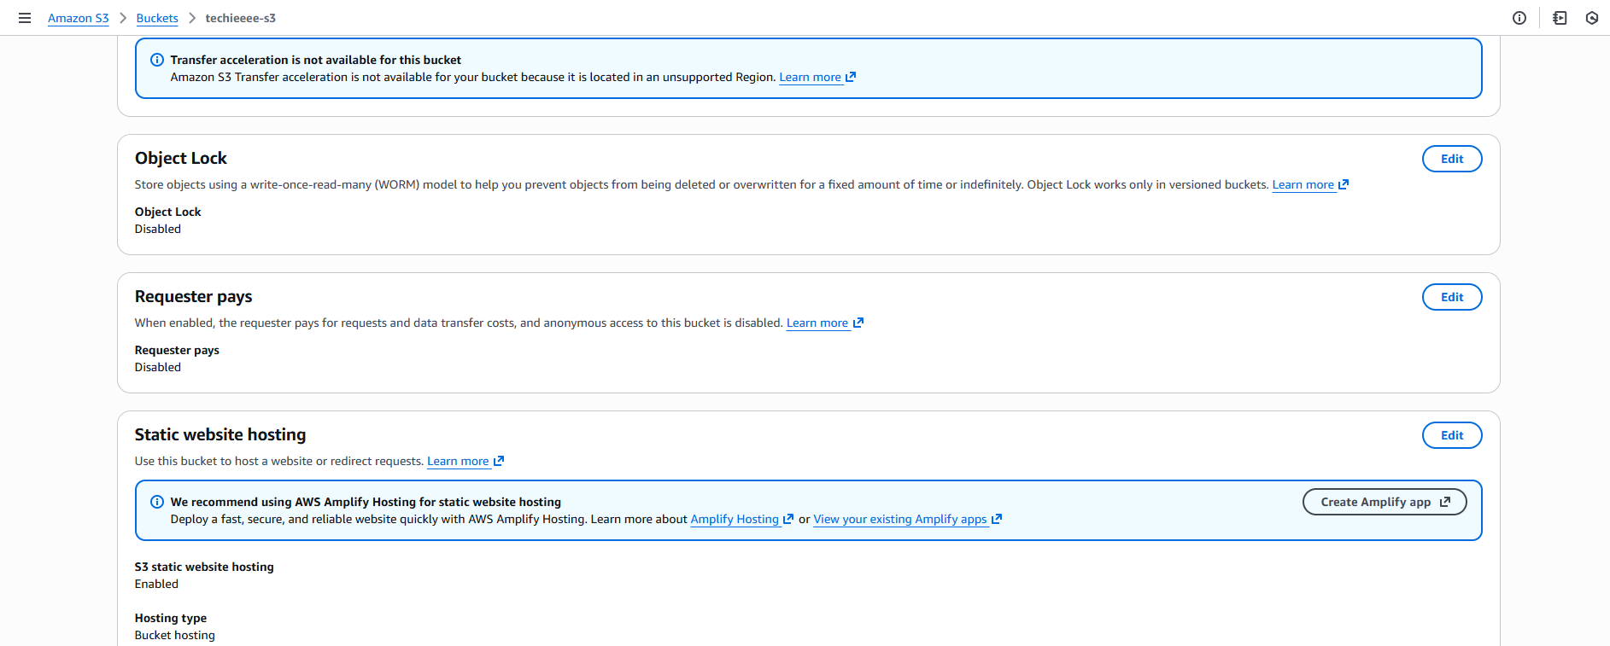

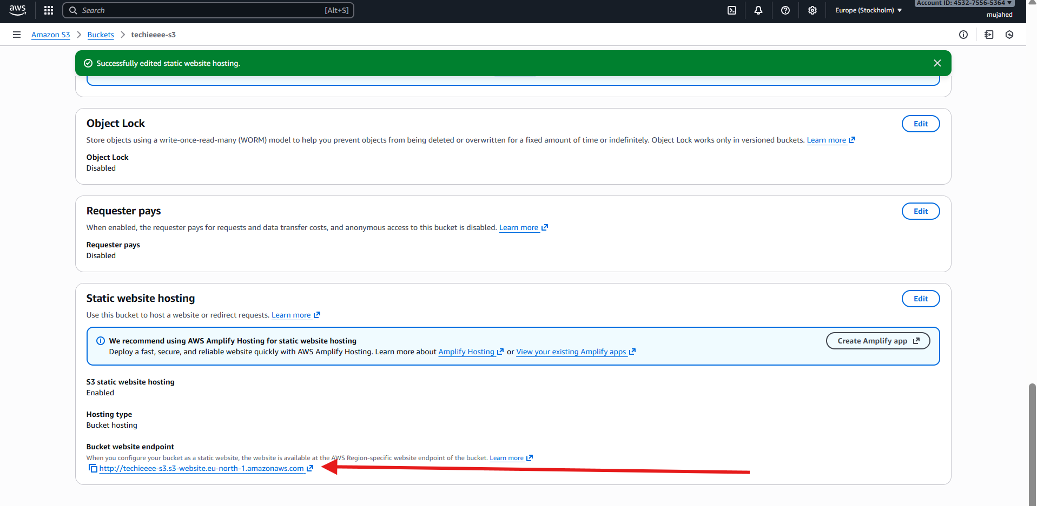

Index.html

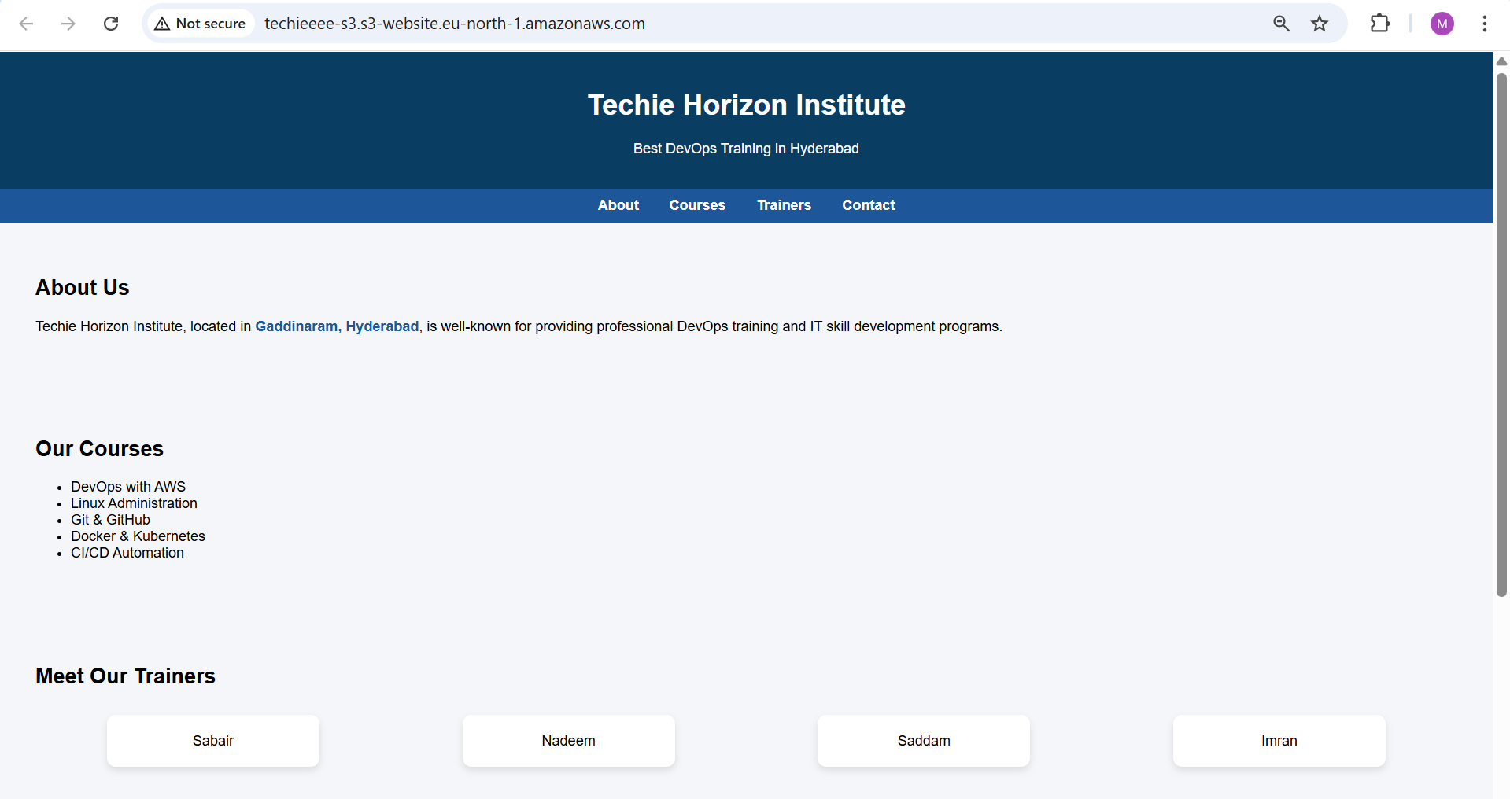

error.html

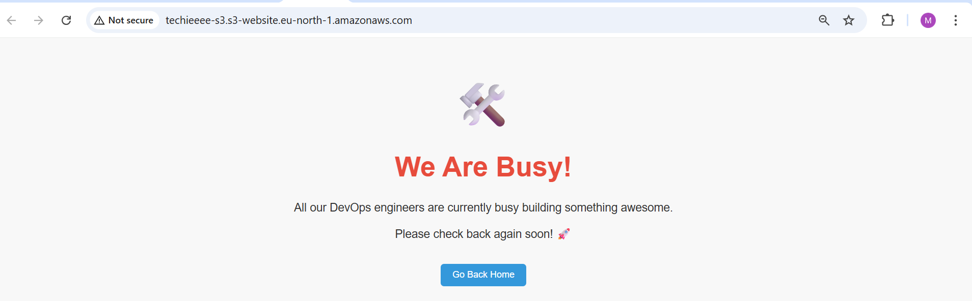

1. Enable cross-region replication on S3 buckets.

* **Create Destination Bucket**
* Region selected: **Asia Pacific (Hyderabad) ap-south-2**
* Bucket name: **mujiu-bucket-1**
* Under **Object Ownership**, selected:
* **ACLs enabled**
* Under **Block Public Access**
* Unchecked **Block all public access**
* Created the bucket
* **Enable Bucket Versioning**
* Opened bucket → **Properties** tab
* Clicked **Edit** under Bucket Versioning
* Selected:
* **Enable**
* **Create Replication Rule (CRR)**
* Open **Source bucket**: techieeee-s3 (Europe Stockholm eu-north-1)
* Go to **Management** tab
* Scroll down → **Create replication rule**
* **Configure Replication Rule**
* Rule name: **europe-hyderabad**
* Status: Enabled
* Source bucket scope:  
  → **Apply to all objects in the bucket**
* Destination:  
   **Choose a bucket in this account**  
  → Selected **mujiu-bucket-1**  
  → Region: **Asia Pacific (Hyderabad)**
* **IAM Role for Replication**
* Selected:  
   **Create new role**
* AWS automatically created IAM permissions for replication
* **Replication Rule Successfully Created**
* Rule status shows:
* **Enabled**
* Scope: Entire bucket
* Replication: Active
* Replication is now set from:
* Source: techieeee-s3 (eu-north-1)  
  Destination: mujiu-bucket-1 (ap-south-2)
* **Make Object Public**
* Go to the source S3 bucket
* Selected the object: **Git-Commands**
* Clicked **Object actions**
* Selected:  
   **Make public using ACL**
* Now the file is publicly accessible via object URL

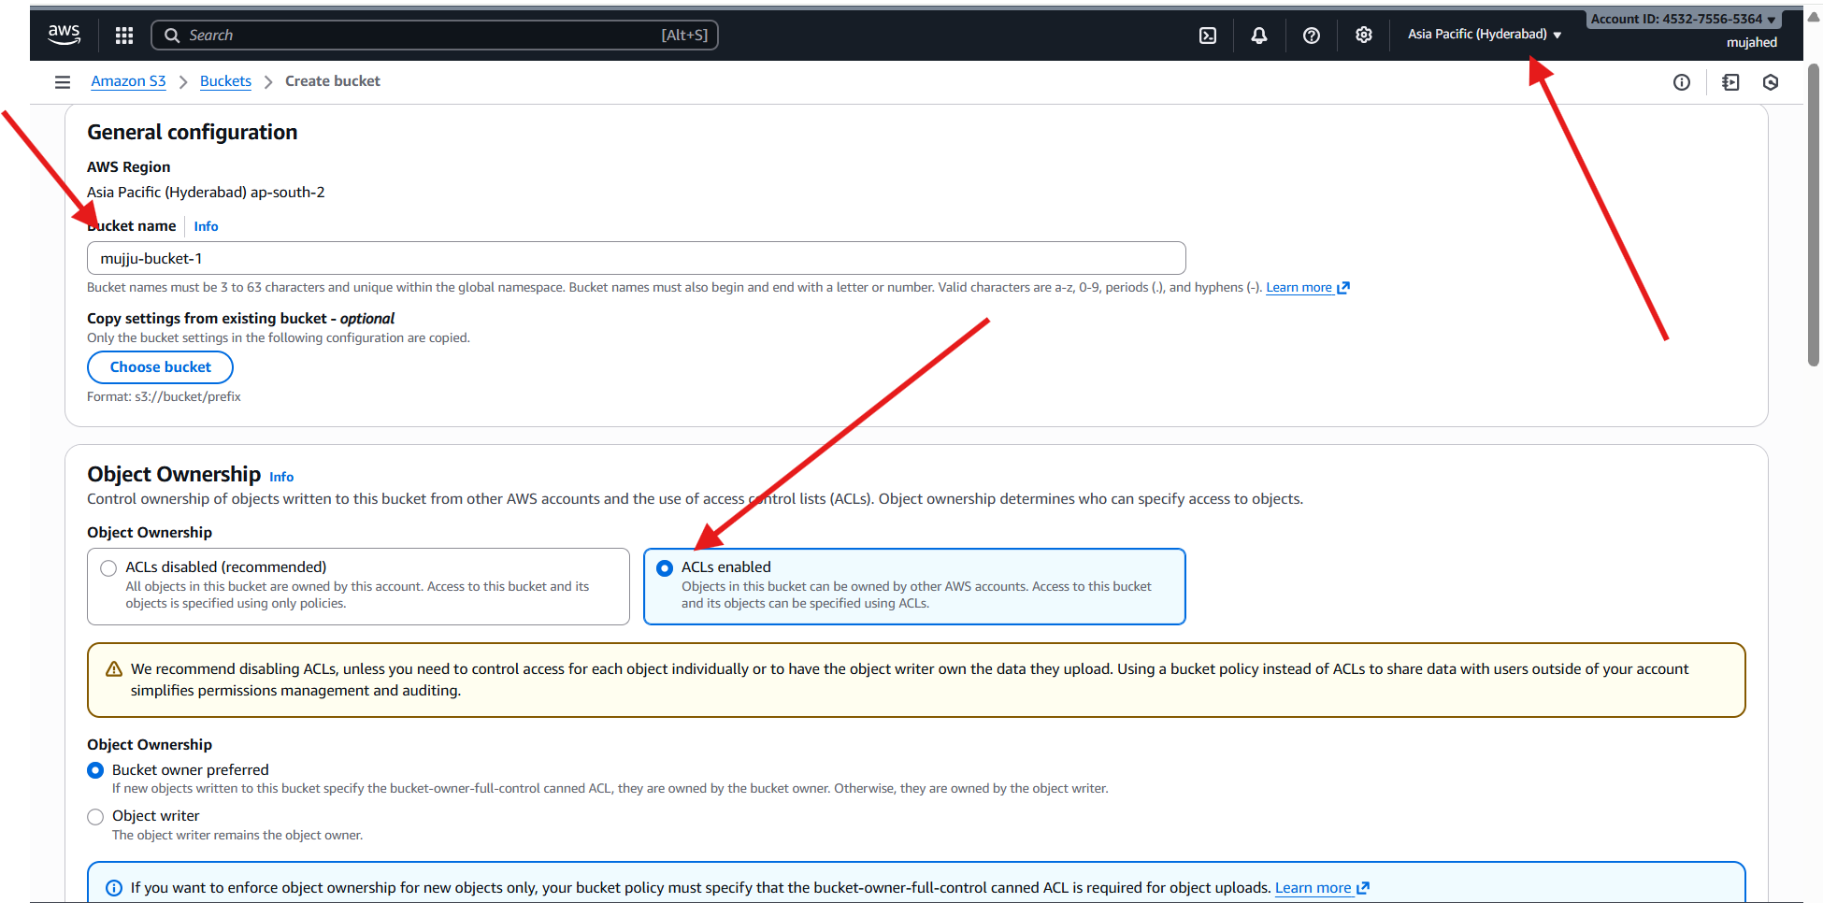

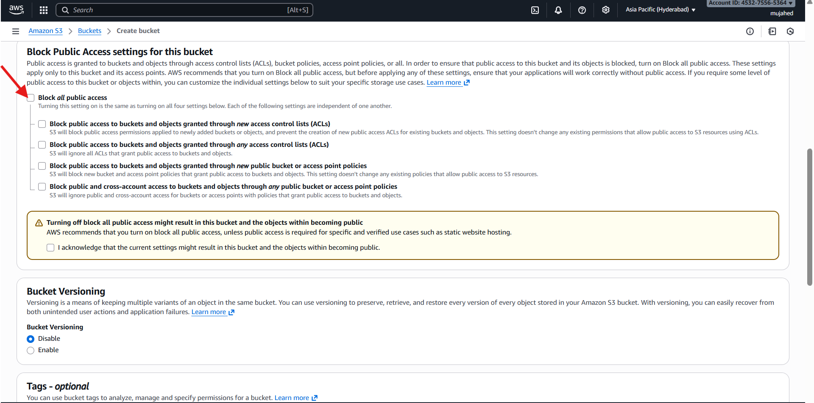

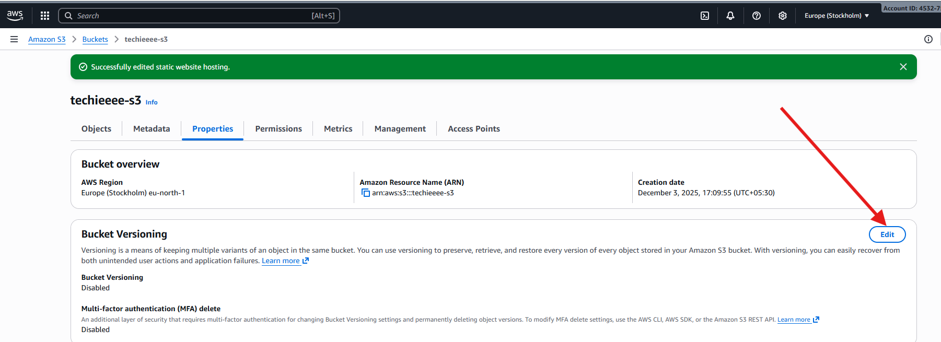

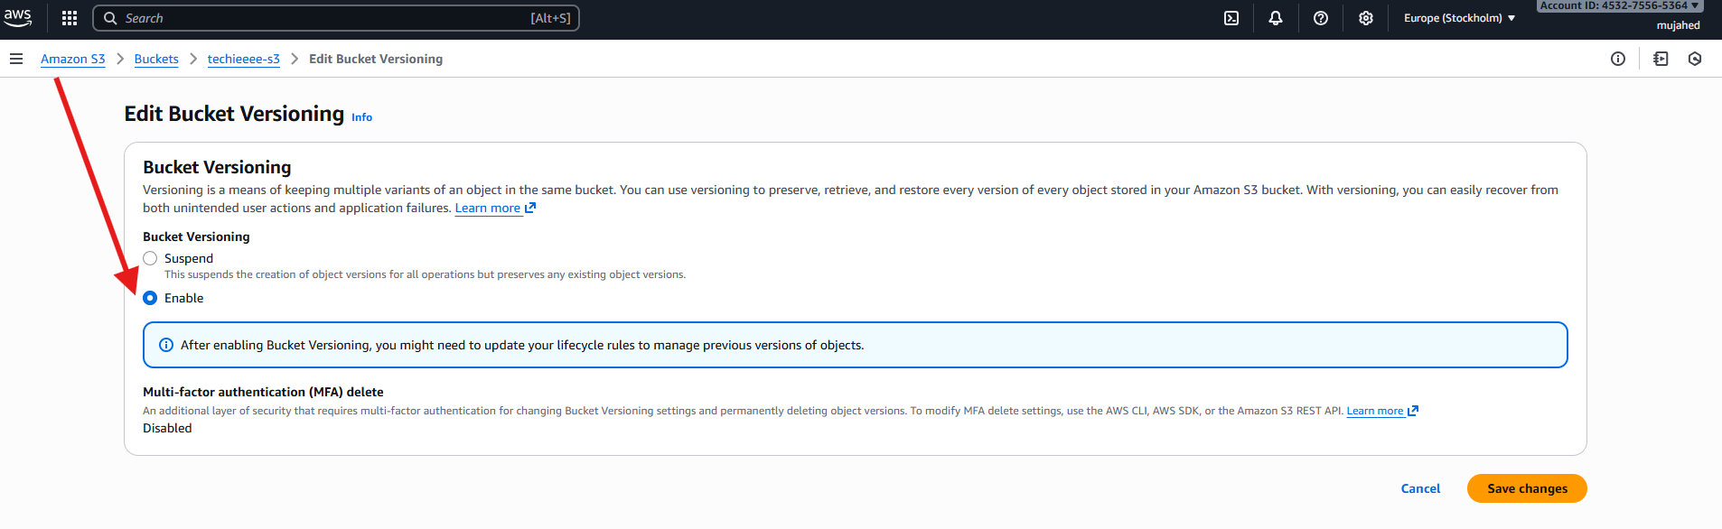

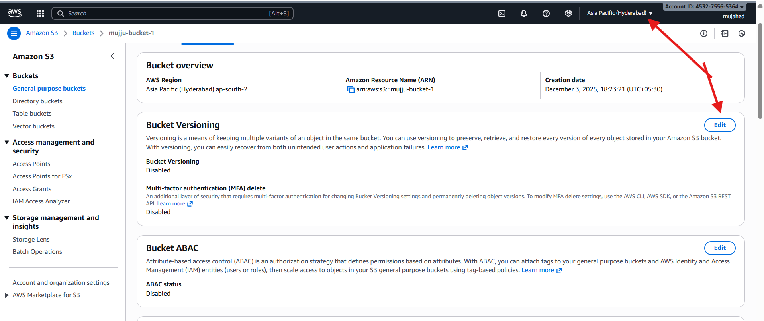

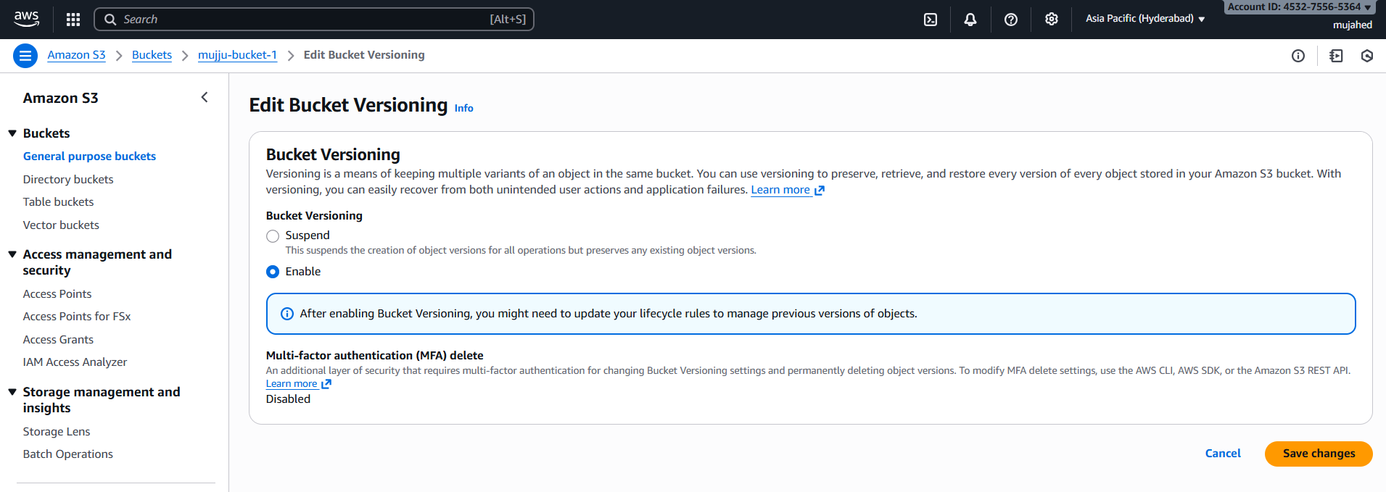

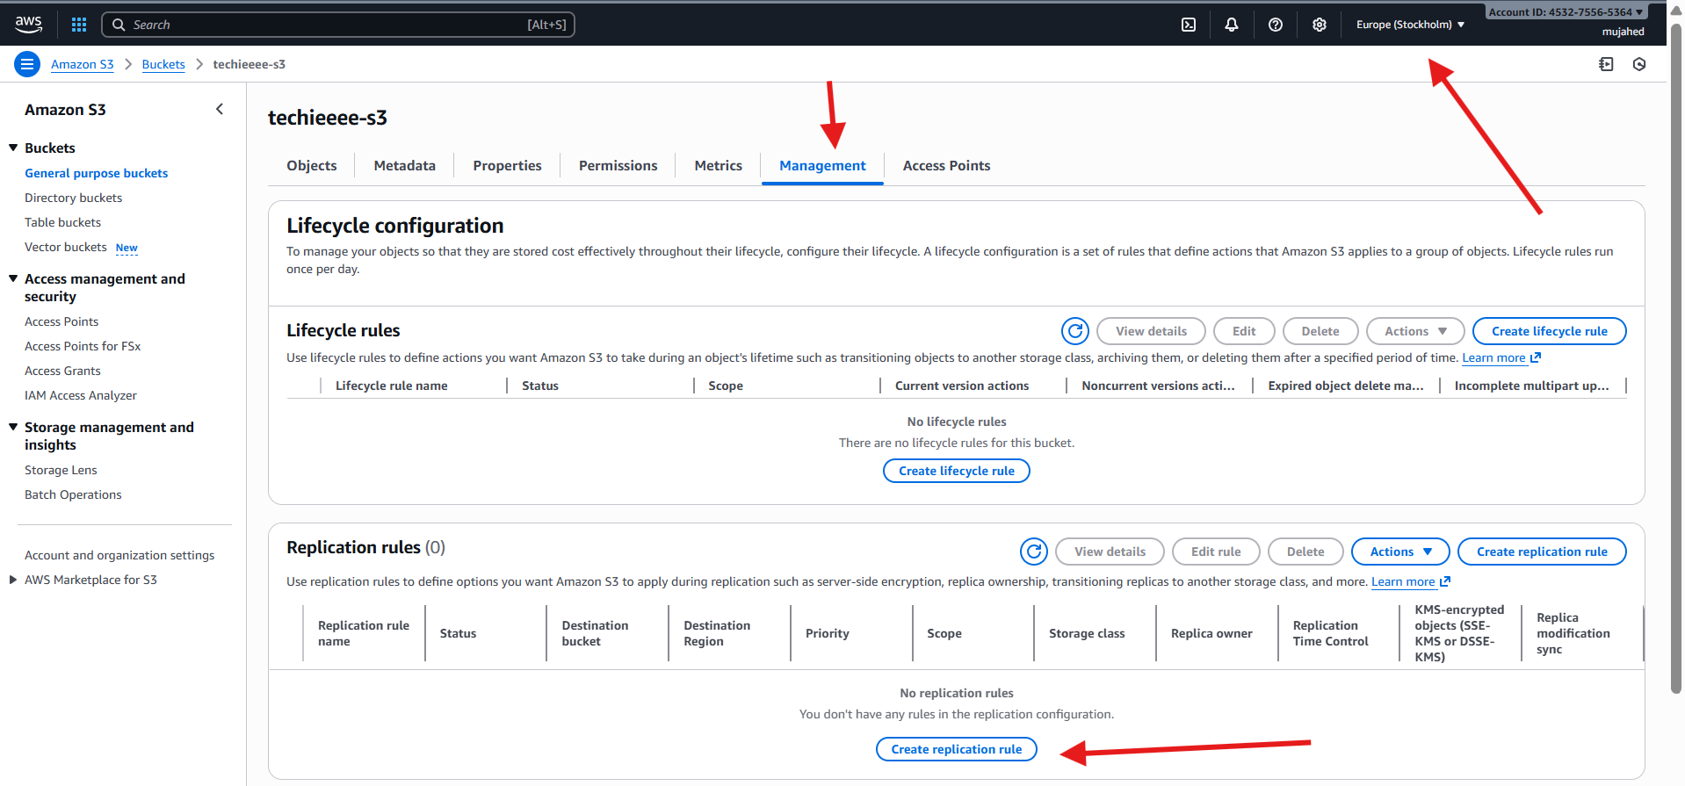

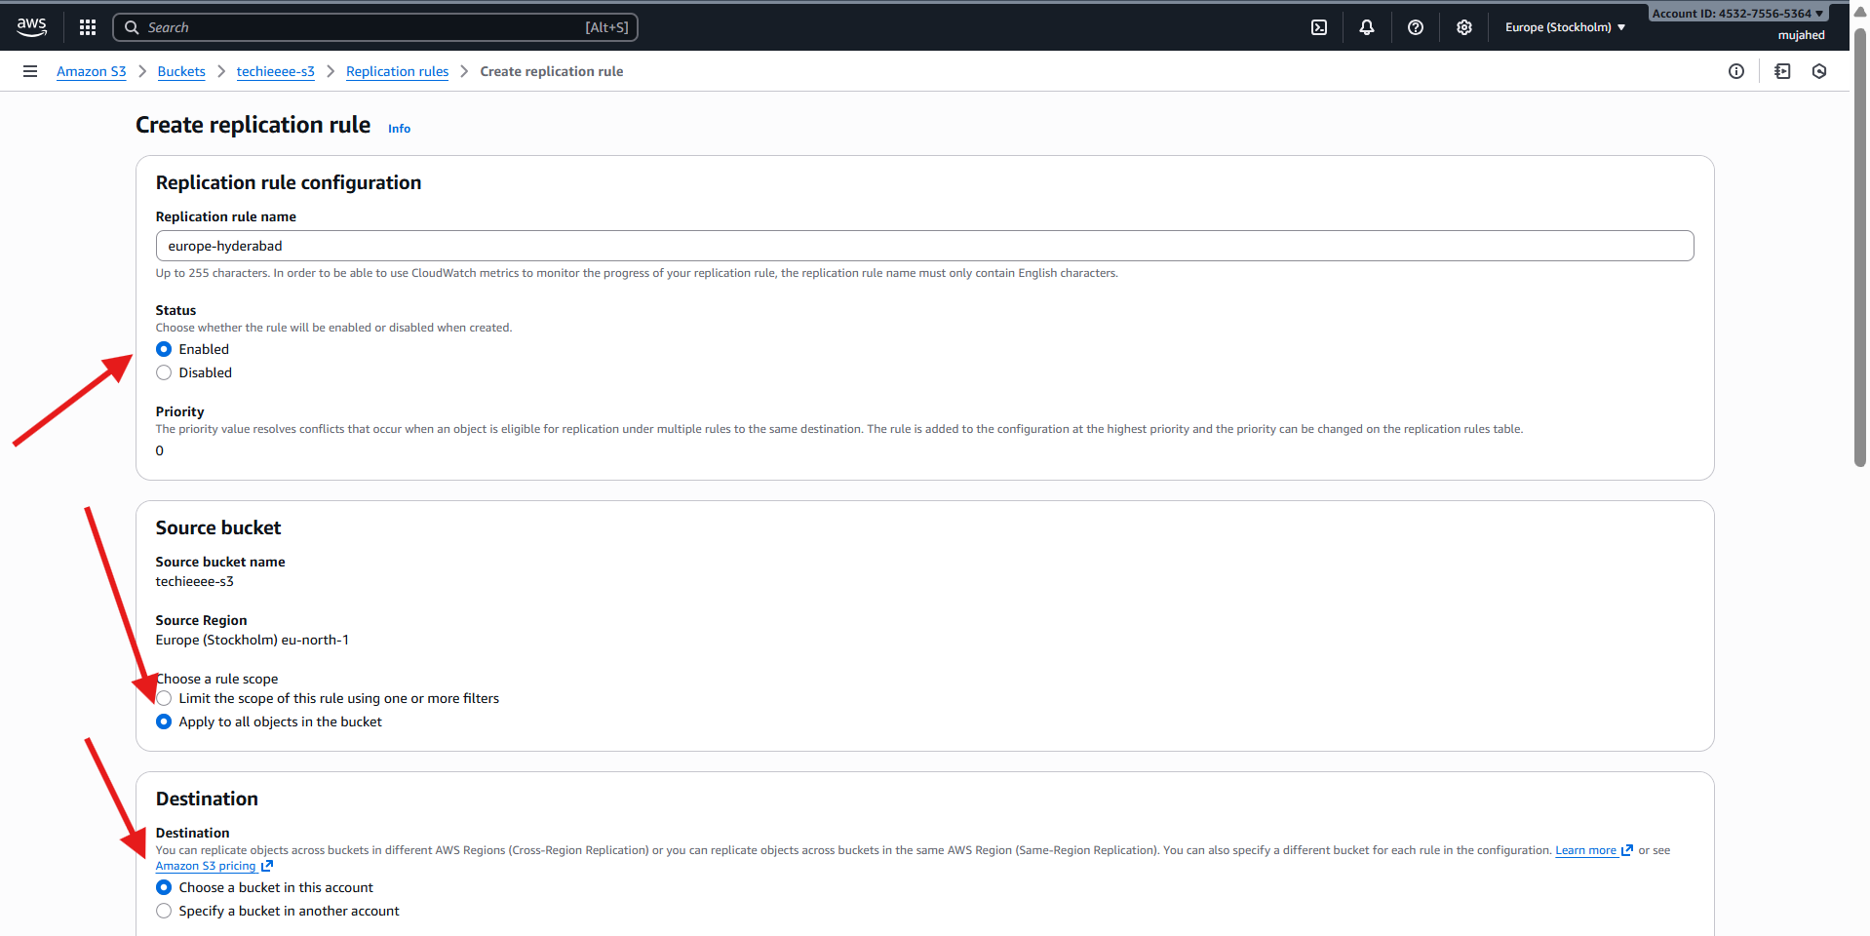

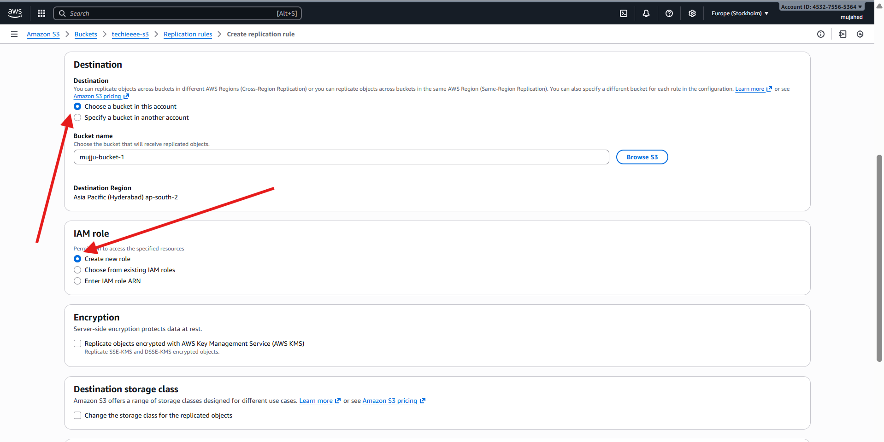

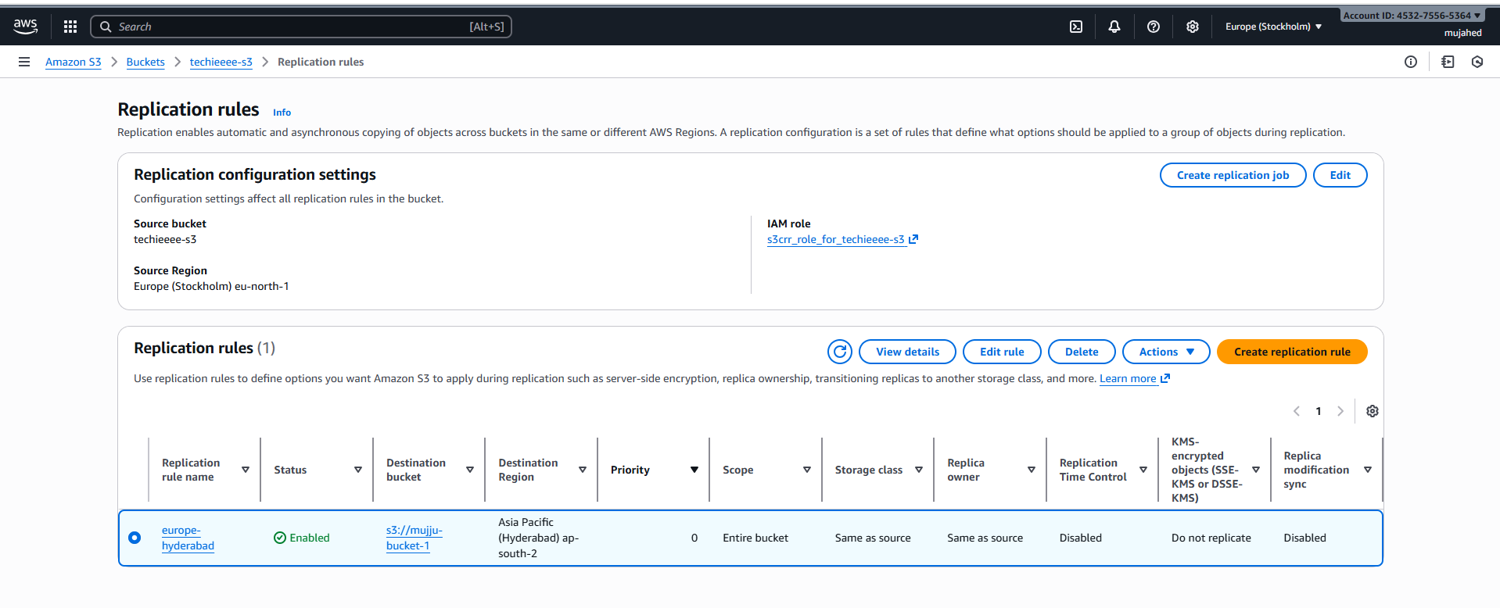

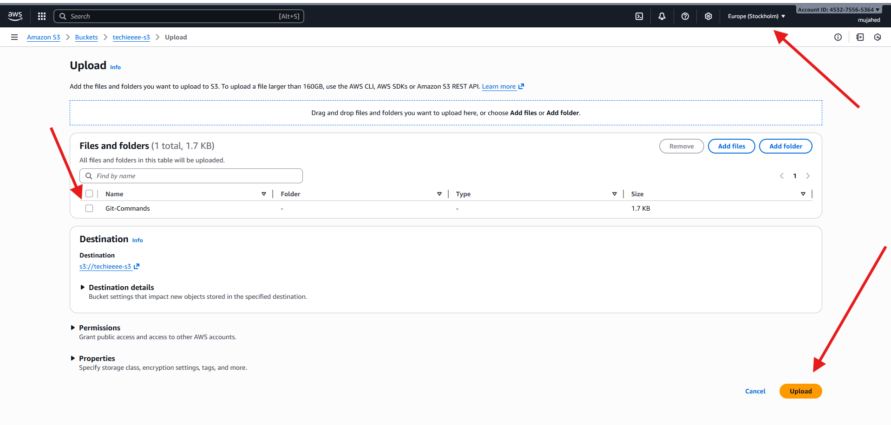

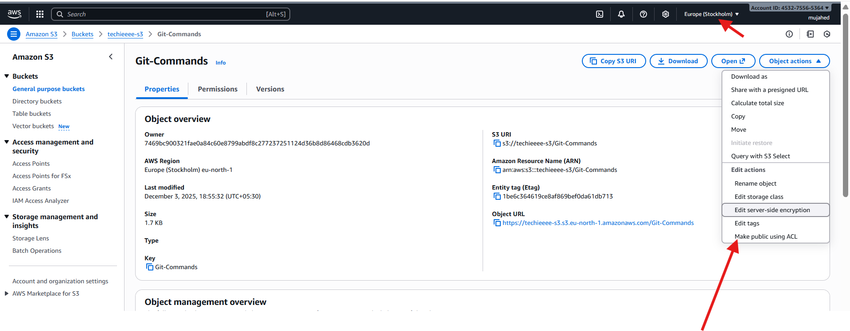

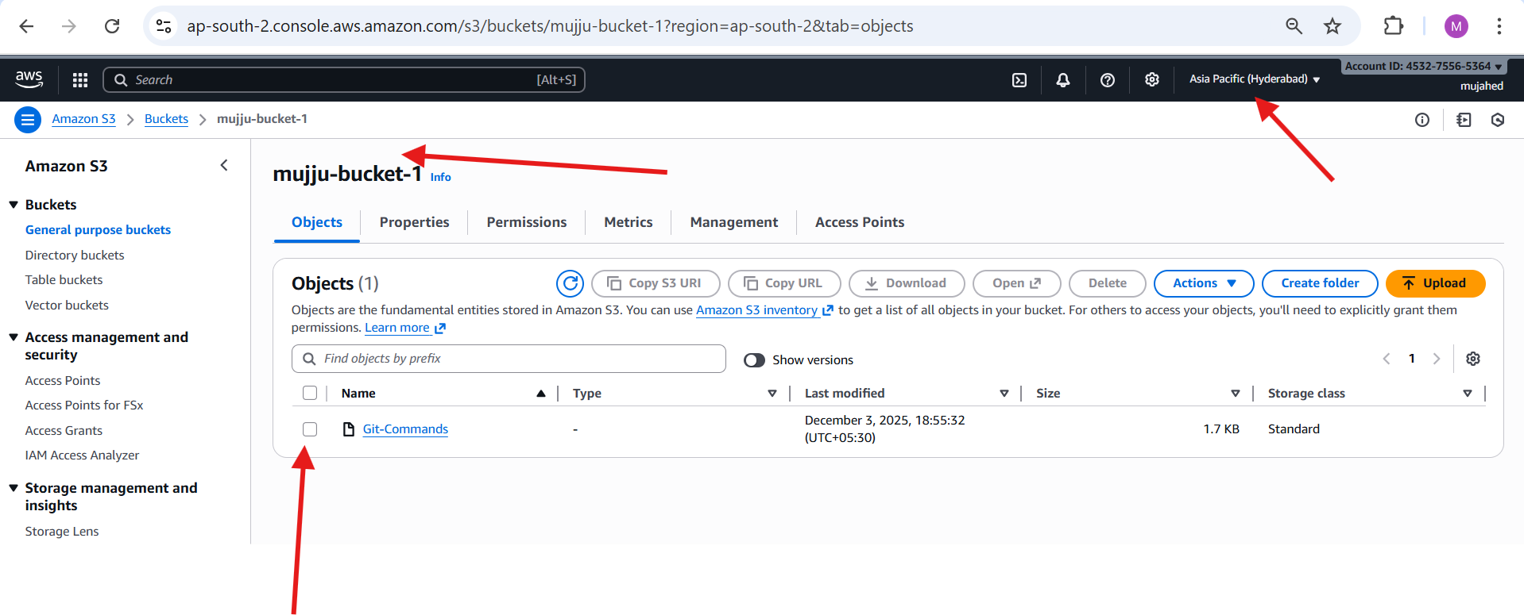

1. Configure a bucket policy so only the Admin user can see the objects of the S3 bucket.

➡ Opened **IAM → Users → IAMUSER-1**  
➡ Checked **Permissions** tab to confirm attached IAM managed policies  
(Policies include S3Access, EC2FullAccess, IAMFullAccess etc.)

➡ Opened **S3 → mujiu-bucket-1 → Permissions tab**  
➡ Selected **Edit** under **Bucket Policy**

➡ Added a **custom bucket policy**  
 Allowed access only to:

* Root Account
* IAMUSER-1  
  ➡ Clicked **Save changes**

➡ Verified **policy successfully applied**  
➡ Block Public Access = Off  
➡ Custom bucket policy shows under Permissions

➡ Opened **Objects tab** of mujiu-bucket-1  
➡ Confirmed uploaded items:

* bigfile1GB.bin
* hero-image.jpg

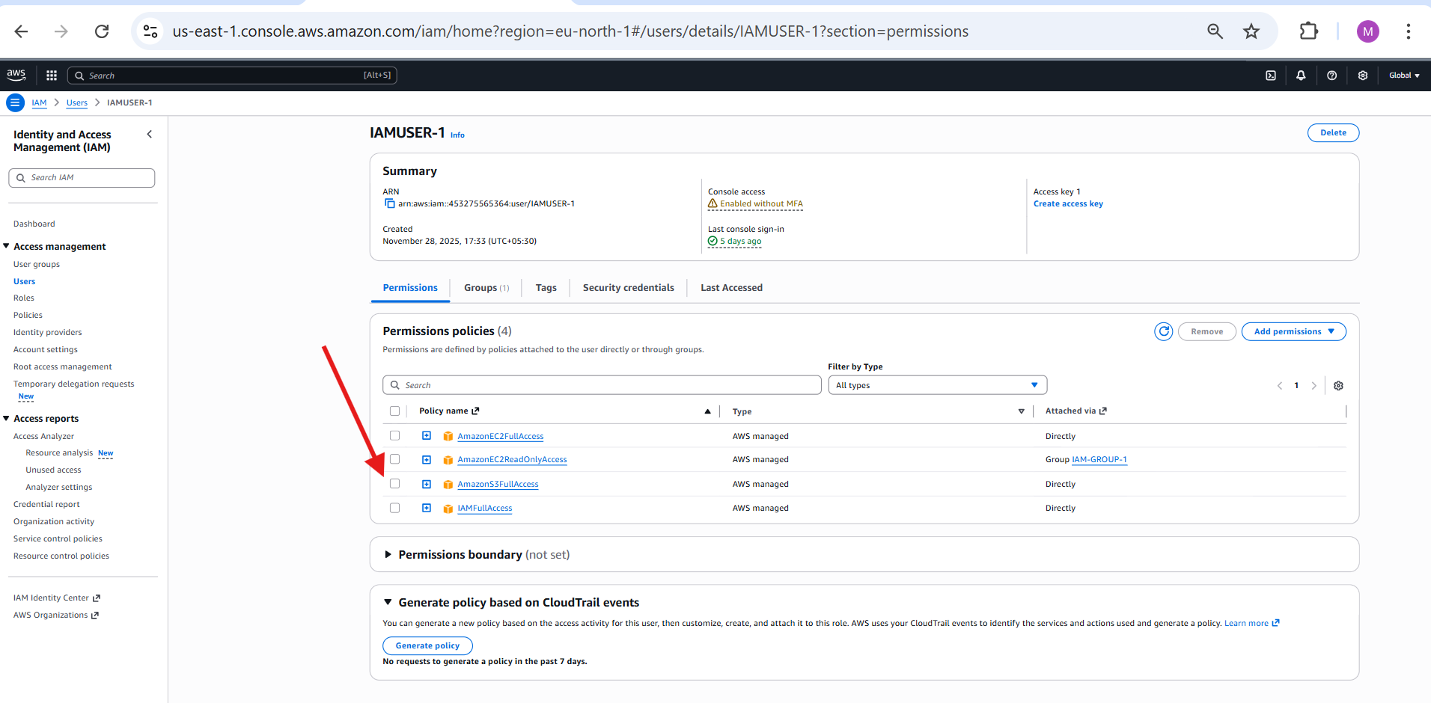

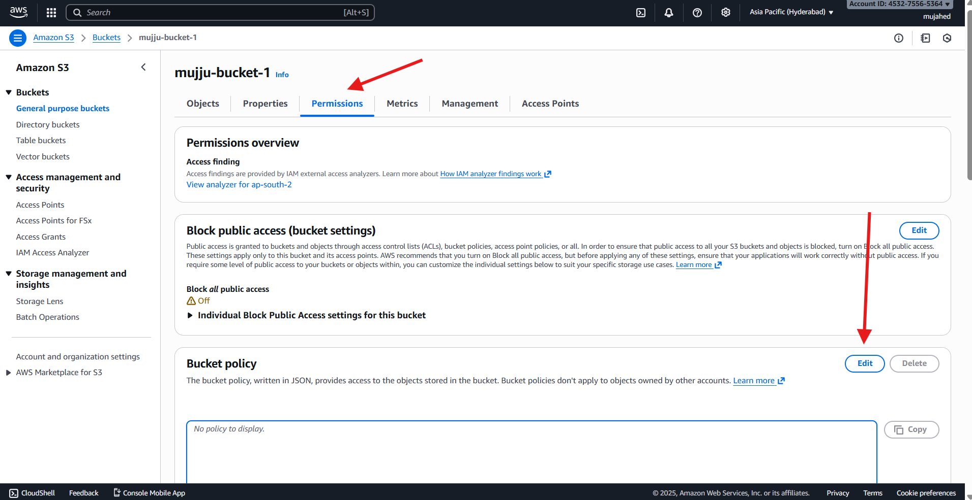

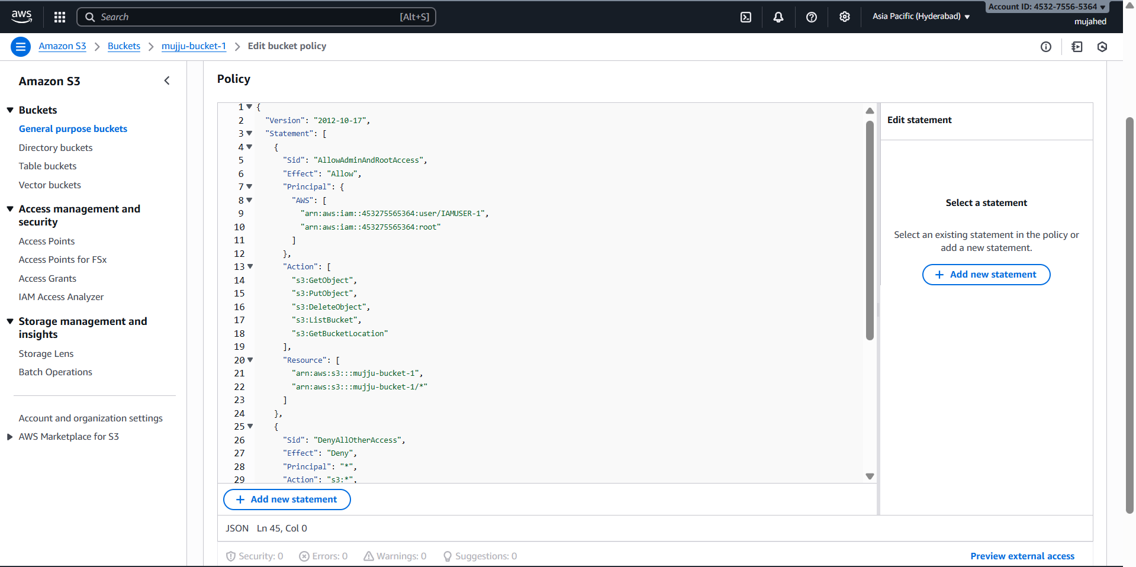

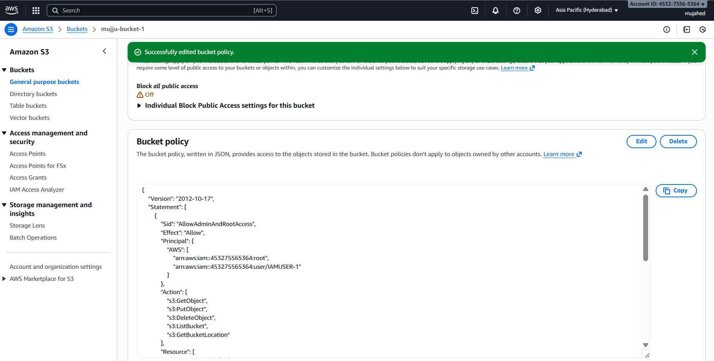

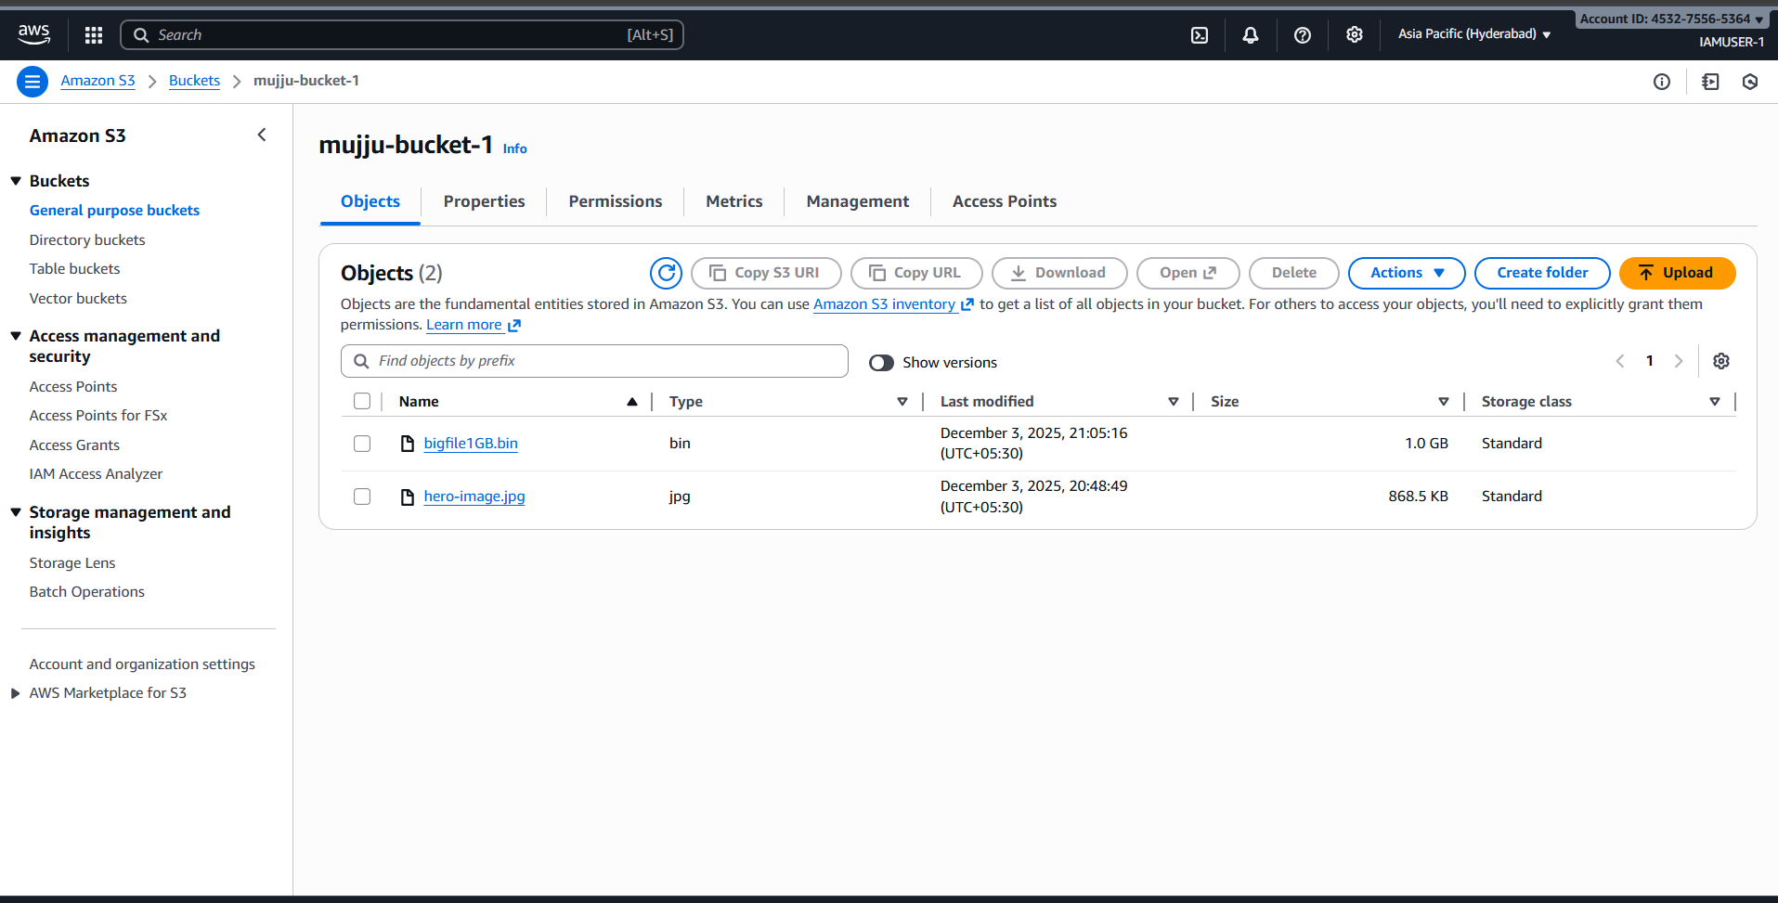



1. Set up lifecycle policies to automatically transition or delete objects based on specific criteria.

### **⬇ Steps Performed in Lifecycle Rule Setup**

Open S3 bucket **techieeee-s3**  
 Select **Management** tab  
Click **Create lifecycle rule**

Enter rule name: **life-cycle-1**  
 Choose: **Apply to all objects in this bucket**  
 Enable lifecycle rule actions:  
 **Expire current versions of objects**  
 Set **30 days** after object creation  
 **Permanently delete noncurrent versions** (used for version-enabled lifecycle control)

Scroll down and review actions  
 Click **Create rule**

Rule created successfully with status: **Enabled**  
 Scope: **Entire bucket**

Current version objects expire after **30 days**  
Noncurrent objects removed after expiration

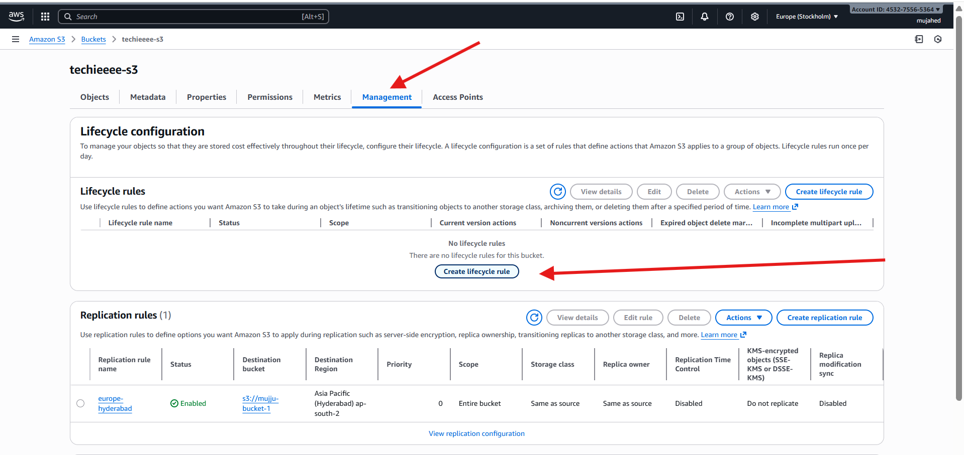

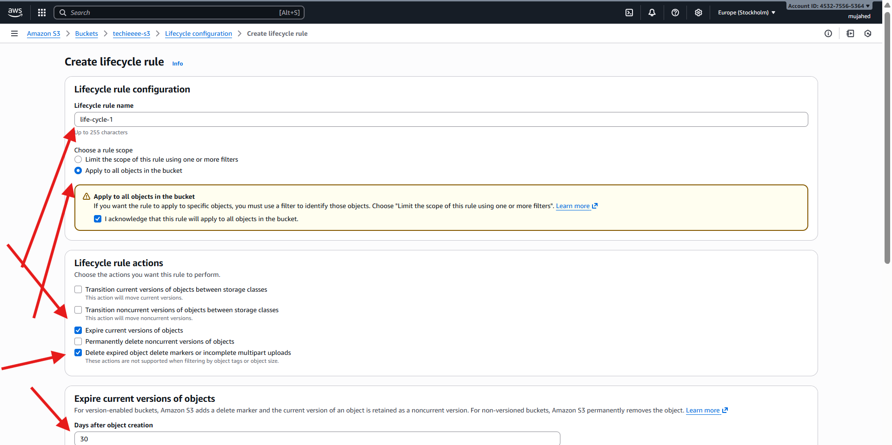

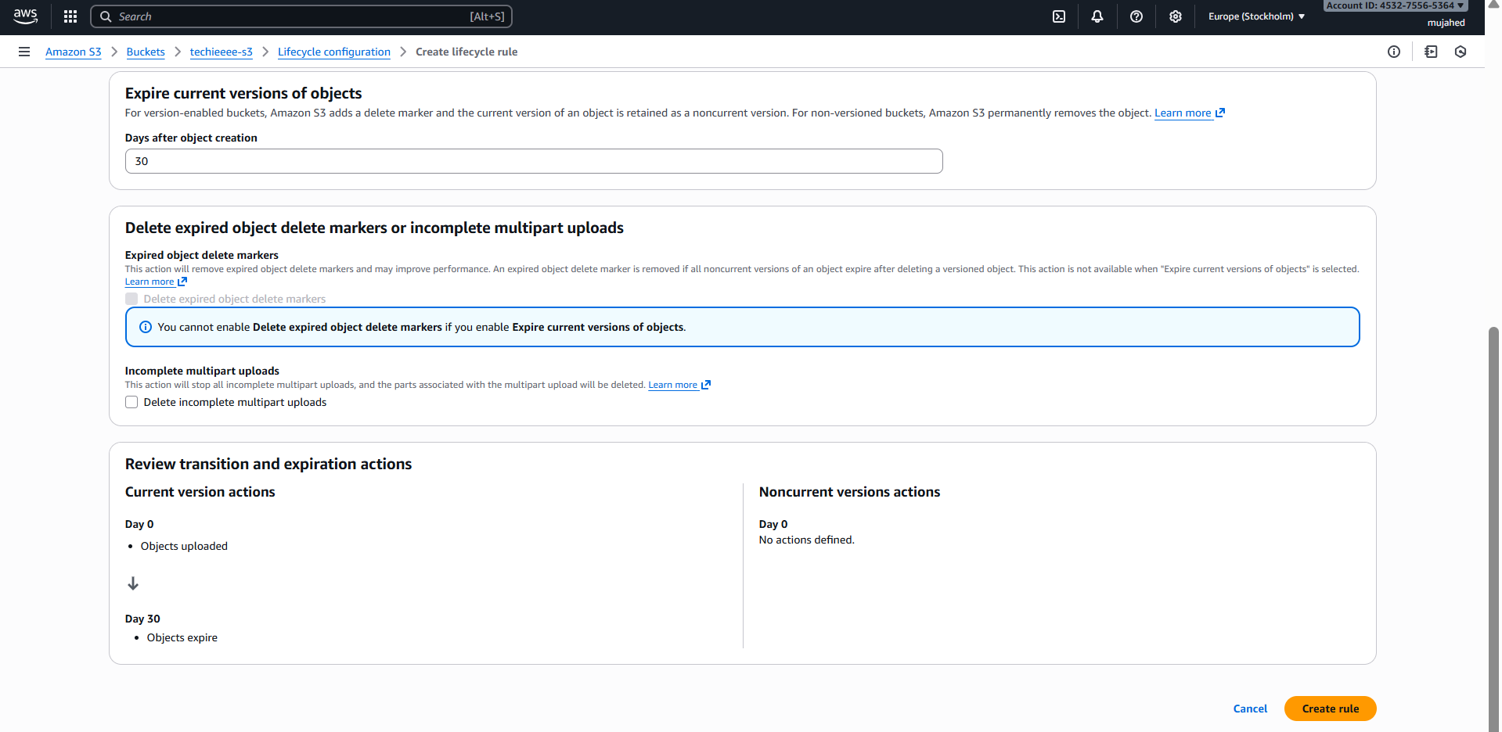

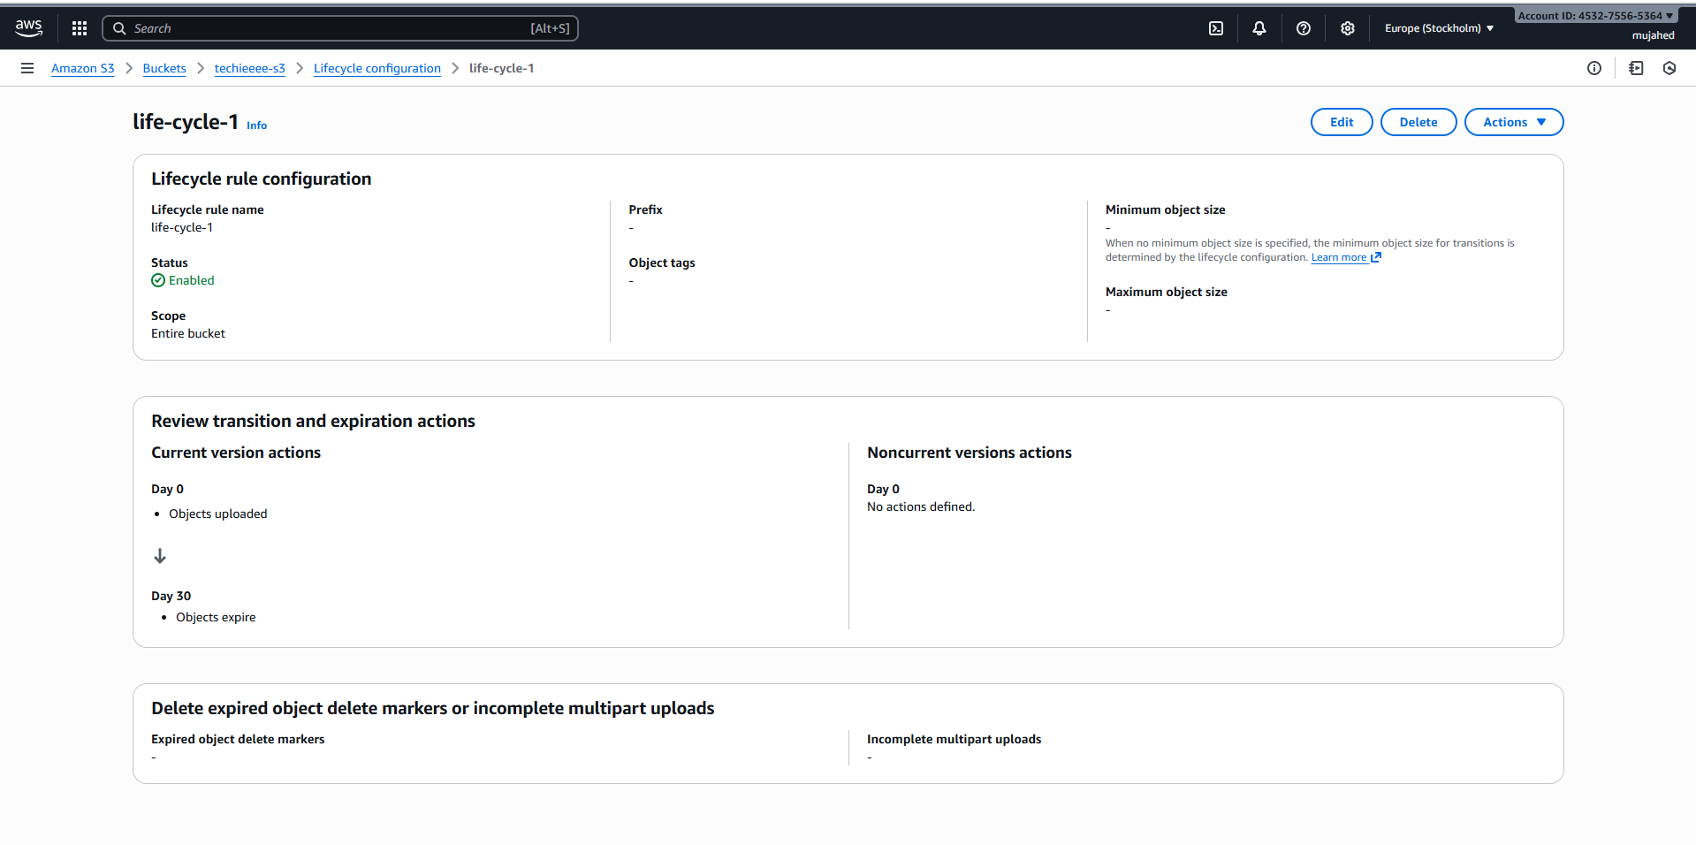

1. Push some objects to S3 using the AWS CLI.

* Open **Git Bash**  
   Go to folder where file exists → Downloads

Run upload command:

aws s3 cp "hero-image.jpg" s3://techieeee-s3/ --region eu-north-1

* Upload successful message displays  
   File now stored in **techieeee-s3** bucket

**⬇ Verify Objects in Bucket**

* Run:
* aws s3 ls s3://techieeee-s3/

Output shows:

* Git-Commands
* error.html
* hero-image.jpg

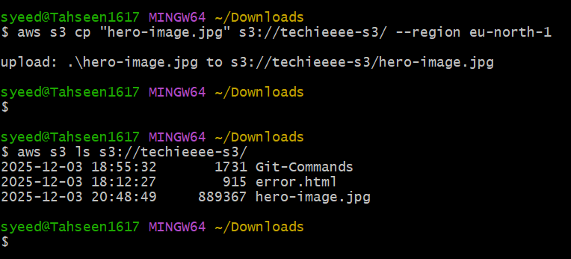

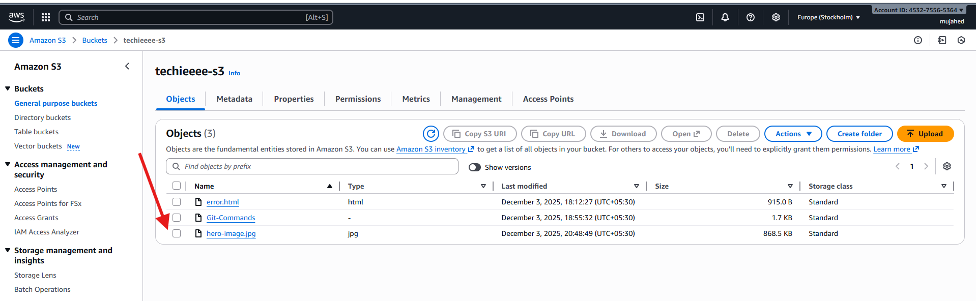

1. Write a Bash script to create an S3 bucket.

**⬇ Create S3 Bucket using Shell Script**

* Open Git Bash  
   Create script file:
* vi create_script.bash
* Give execute permissions:
* chmod 755 create_script.bash
* Run the script:
* ./create_script.bash

First bucket name failed  
➡ Error: **BucketAlreadyExists**  
➡ Bucket name already used by someone else globally

Edited script again with different bucket name  
➡ Error: **InvalidBucketName** (invalid characters used)

Updated script again with valid unique name  
➡ Bucket created successfully:

**ms.tasks3-1617** created in region **eu-north-1**  
 Confirmation message + S3 URI displayed

**⬇ Verify Bucket in AWS Console**

Open **S3 console**  
 Bucket list shows:

* ms.tasks3-1617 newly created
* Other buckets (mujiu-bucket-1, techieeee-s3) also visible

Bucket is confirmed successfully created from CLI script

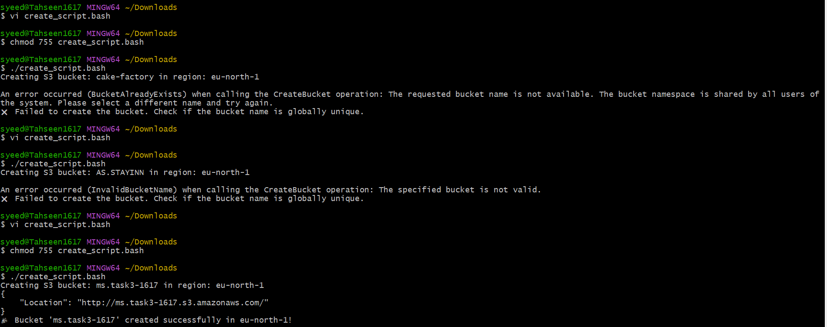

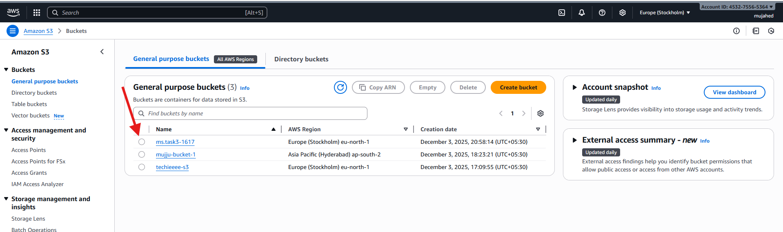

1. Upload a 1 GB file to S3 using the CLI.

**⬇ Create a 1GB Test File in Local System**

* Run command to generate a dummy 1GB file:
* dd if=/dev/zero of=bigfile1GB.bin bs=1M count=1024
* File created successfully in **Downloads** folder  
   Size: **1.0 GiB** (~1.1 GB raw)

**⬇ Upload the 1GB File to S3 Using AWS CLI**

* Upload command executed:
* aws s3 cp bigfile1GB.bin s3://techieeee-s3/ --region eu-north-1
* Upload completed successfully  
  File now available in bucket: **techieeee-s3**

**⬇ Verify in AWS Console**

* Open S3 → Bucket: **techieeee-s3**  
   Objects view shows:
* bigfile1GB.bin → 1.0 GB  
   error.html  
   Git-Commands  
   hero-image.jpg

1GB file upload confirmed

